UNIVERSITY COLLEGE OF SCIENCE AND TECHNOLOGY
Department of Engineering Sciences and Applied Arts · Bachelor of Computer Systems Engineering

Edu Bridge – Smart Scholarship and Student Services Management System
System Analysis & Database Design
ERD · UML diagrams · Data dictionary · SQL · Activity & state models
Prepared by | Alaa Suleiman Abdulrahman Abu Mustafa · 220217287  Database design & integration
With contributions from | Lamia Fathi Hamdi Madi (220217142) — Backend development (PHP API)  Nada Musa Abdul Qader Al-Asital (220217234) — Frontend development (React.js)  Janeen Osama Atiya Al-Qutati (220217280) — AI recommendation, CRM & evaluation
Course supervisor | Ms. Amina Al-Salout
Academic year | 2026/2027
Document version | 1.0 — October 2026

Document information
This report is a team deliverable of the graduation project. The table below shows which student prepared each part, so the supervisor can see the individual work of every team member.
Table 1: Contribution of each student
Part of this document | Prepared by | Student ID
Database design: ERDs, normalisation, keys, data dictionary, SQL, reporting views, security, backup (§9) | Alaa Suleiman Abdulrahman Abu Mustafa | 220217287
System architecture, back-end class diagram, sequence diagrams, API mapping (§3, §5.2, §6, §10) | Lamia Fathi Hamdi Madi | 220217142
Use case modelling and activity diagrams, user flows (§4, §7) | Nada Musa Abdul Qader Al-Asital | 220217234
Domain model and state diagrams of the workflow and CRM (§5.1, §8) | Janeen Osama Atiya Al-Qutati | 220217280
Requirements analysis (§2) and review of the whole document | All team members | —

Table 2: Document details
Item | Value
Project | Edu Bridge – Smart Scholarship and Student Services Management System
Database | MySQL 8 / MariaDB 10.4 — edubridge (25 tables, 7 views)
Source files | edubridge-api/database/schema.sql, seed.sql, views.sql
Diagram notation | UML 2.5 (use case, class, sequence, activity, state) and crow’s-foot ERD

How to read the diagrams
All diagrams were produced from text definitions (Mermaid) kept in the repository, so they can be updated together with the code.

Table of Contents
Document information 2
1. Introduction 5
1.1 Purpose of this document 5
1.2 Scope 5
1.3 System overview 5
1.4 Definitions 5
2. Requirements Analysis 6
2.1 Actors 6
2.2 Functional requirements 6
2.3 Non-functional requirements 7
3. System Architecture 8
4. Use Case Modeling 10
4.1 Use case descriptions 12
5. Class Diagrams 14
5.1 Domain model 14
5.2 Back-end design classes 14
6. Sequence Diagrams 17
6.1 Sign in 17
6.2 Upload a document and update readiness 18
6.3 Service request handled by an advisor 19
7. Activity Diagrams 20
7.1 Student registration 20
7.2 Scholarship application journey 21
8. State Diagrams 22
8.1 Application (8 stages) 22
8.2 Document 23
8.3 Service request 23
8.4 Scholarship and admission results 24
8.5 User account 25
9. Database Design 26
9.1 Design approach 26
9.2 Conceptual ERD 26
9.3 Logical ERDs by module 27
9.4 Normalisation 29
9.5 Keys, constraints and indexes 30
9.6 Data dictionary 30
9.7 SQL implementation 38
9.8 Security 40
9.9 Backup and recovery 40
10. API and Database Mapping 42
11. Conclusion 43

If page numbers do not appear, right-click the table and choose “Update Field”.

1. Introduction

1.1 Purpose of this document
This document presents the complete system analysis and database design of EduBridge – Smart Scholarship and Student Services Management System. It translates the approved project proposal into analysis models (use cases, UML class, sequence, activity and state diagrams) and into a concrete relational database implemented in MySQL / MariaDB. Every model in this document matches the database and REST API that are already running in the project repository (edubridge-api).

1.2 Scope
The analysis covers the three portals of the system — Student, Advisor (Employee) and Administrator — and the automated services that support them (matching engine, readiness score, notifications). The database design covers 25 tables, their keys and constraints, reporting views, security and backup.

1.3 System overview
EduBridge replaces the scattered WhatsApp-based workflow of an educational consultancy office with one centralised web platform. Students build a profile, upload their documents once, discover suitable scholarships and follow every step of their application. Advisors manage students, documents, service requests and applications from one CRM, and administrators manage users and view statistics.
Table 3: Technology summary
Item | Value
Front end | React.js 18 (Vite), React Router, react-i18next (Arabic RTL / English LTR)
Back end | PHP 8 REST API (no framework), JWT authentication
Database | MySQL 8 / MariaDB 10.4 — utf8mb4, InnoDB, 25 tables, 7 reporting views
AI | Rule-based weighted matching + Groq API (pre-trained LLM) for explanations
Tools | Git & GitHub · Postman & Swagger (OpenAPI 3) · phpMyAdmin · XAMPP

1.4 Definitions
Table 4: Definitions
Term | Meaning
Readiness score | Percentage (0–100) showing how complete a student’s required documents are.
Match score | Weighted score (0–100) showing how well a student profile fits a scholarship.
Stage | Position of an application in the 8-stage workflow (New request → Accepted / Rejected).
CRM | Customer Relationship Management — the advisor workspace for students, notes and communication.
JWT | JSON Web Token used to authenticate API requests; one token per signed-in device.

2. Requirements Analysis

2.1 Actors
Table 5: System actors
Actor | Description | Main goals
Student | Applicant who wants a scholarship or a consultancy service. | Build profile, upload documents, find scholarships, request services, track applications.
Advisor / Employee | Edu Bridge staff member who follows students. | Review documents, handle requests, move applications through stages, log communication.
Administrator | Manages the platform. | Manage users and roles, scholarships, reports and settings.
Scheduler + matching engine | Automated part of the system (no human). | Compute match & readiness scores, send reminders, close expired scholarships.

2.2 Functional requirements
Table 6: Functional requirements
ID | Requirement | Actor | Priority
FR-01 | Register a student account in five steps and confirm the email address. | Student | High
FR-02 | Sign in, sign out and reset the password with a 6-digit code. | All | High
FR-03 | Manage personal, academic, language and preference information. | Student | High
FR-04 | Upload, replace and delete documents (PDF, JPG, PNG, DOCX ≤ 10 MB). | Student | High
FR-05 | Calculate the readiness score and list missing documents. | System | High
FR-06 | Search and filter scholarships by level, country, field and funding. | Public / Student | High
FR-07 | Calculate a match score and classify Eligible / Potentially suitable / Not suitable. | System | High
FR-08 | Request one of seven services and follow its status. | Student | High
FR-09 | Track applications through eight stages with history. | Student / Advisor | High
FR-10 | Review documents (approve / reject with a reason). | Advisor | High
FR-11 | Assign requests, add notes and log calls / WhatsApp / emails. | Advisor | Medium
FR-12 | Create and edit scholarships with full eligibility criteria. | Advisor / Admin | High
FR-13 | Track admission results per scholarship. | Advisor | Medium
FR-14 | Send notifications and deadline reminders. | System | Medium
FR-15 | Manage users, roles and permissions. | Admin | High
FR-16 | Show statistics: students, requests, applications, countries, services, acceptance, workload. | Admin | Medium
FR-17 | Manage signed-in devices, email, password and notification preferences. | All | Medium
FR-18 | Receive public “Contact us” messages. | Public | Low

2.3 Non-functional requirements
Table 7: Non-functional requirements
ID | Category | Requirement
NFR-01 | Security | Passwords hashed with bcrypt; every SQL query uses prepared statements; role-based access on every route.
NFR-02 | Security | Uploaded files stored outside the public folder with random names; MIME type checked from file content.
NFR-03 | Usability | Full Arabic (RTL) and English (LTR) interface; responsive from 360 px phones to desktops.
NFR-04 | Performance | API responses under 500 ms for normal queries; match results cached in match_scores.
NFR-05 | Reliability | Daily database backup; transactions for multi-table writes.
NFR-06 | Maintainability | Layered code (controllers, services, core); API documented with Swagger and Postman.
NFR-07 | Ethics | AI output is decision support only and never claims guaranteed admission.

3. System Architecture
EduBridge follows a three-tier architecture. The React single-page application is the presentation layer. It talks to the PHP REST API over HTTPS using JSON. The API is the only component allowed to access the MySQL database and the file storage, and it calls external services (Groq API for language-model explanations, SMTP for email) through dedicated service classes.
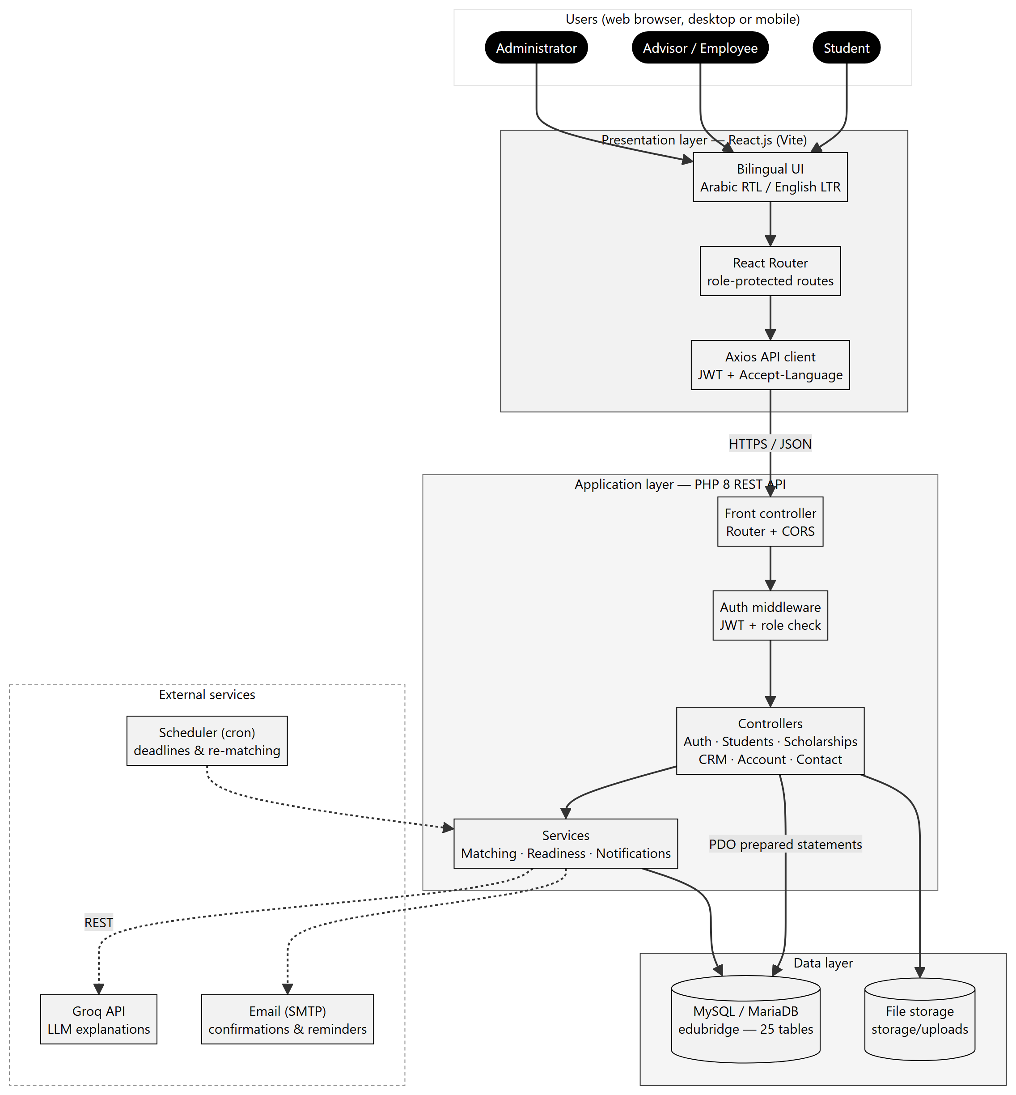
Figure 1: Three-tier architecture of EduBridge

Request flow
- The browser sends a request with Authorization: Bearer <JWT> and Accept-Language headers.
- The front controller (public/index.php) applies CORS and routes the request.
- The auth middleware checks the token, the session row and the role required by the route.
- The controller validates input, calls services and runs prepared SQL statements.
- A unified JSON response (or { "error": { … } }) is returned.

4. Use Case Modeling
The use cases are split by actor to keep each diagram readable. Shared use cases such as signing in appear for every actor.
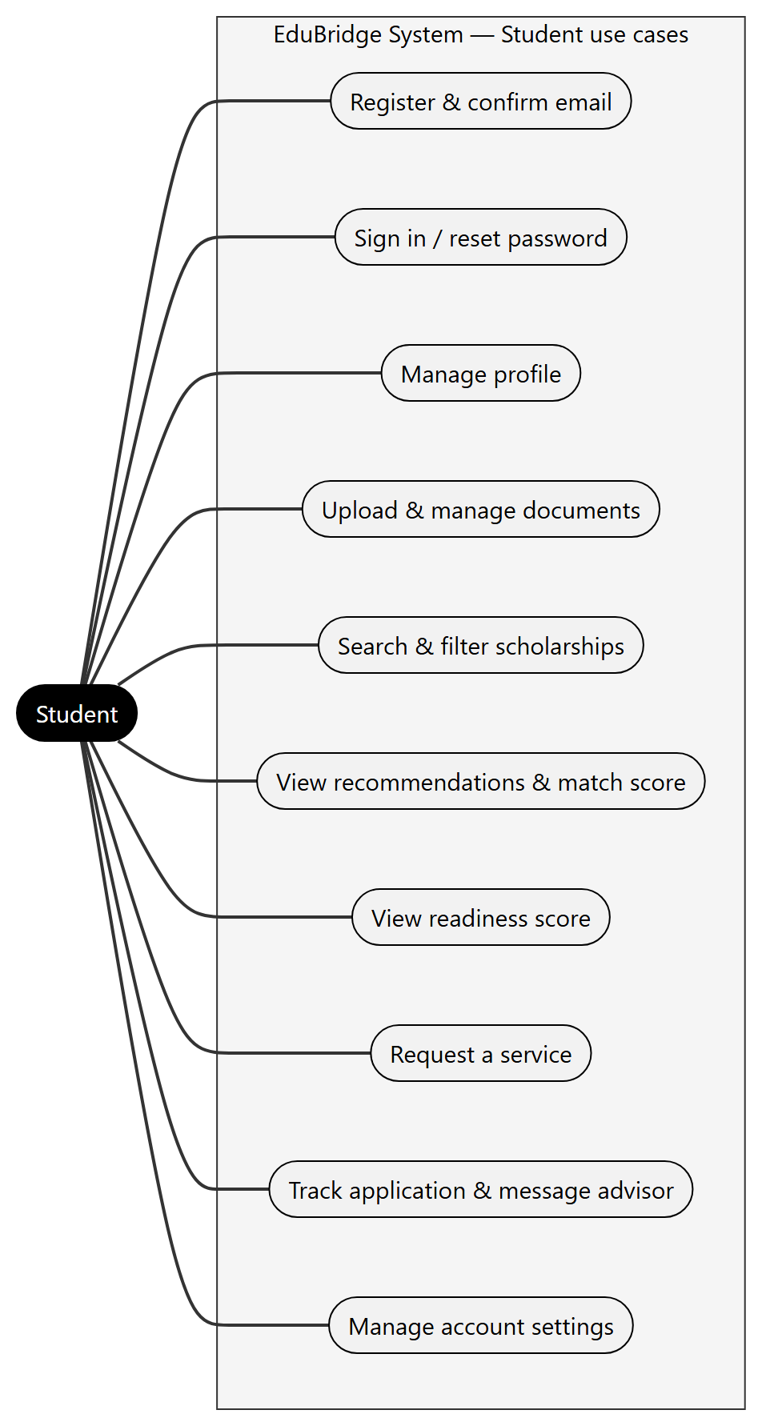
Figure 2: Use case diagram — Student
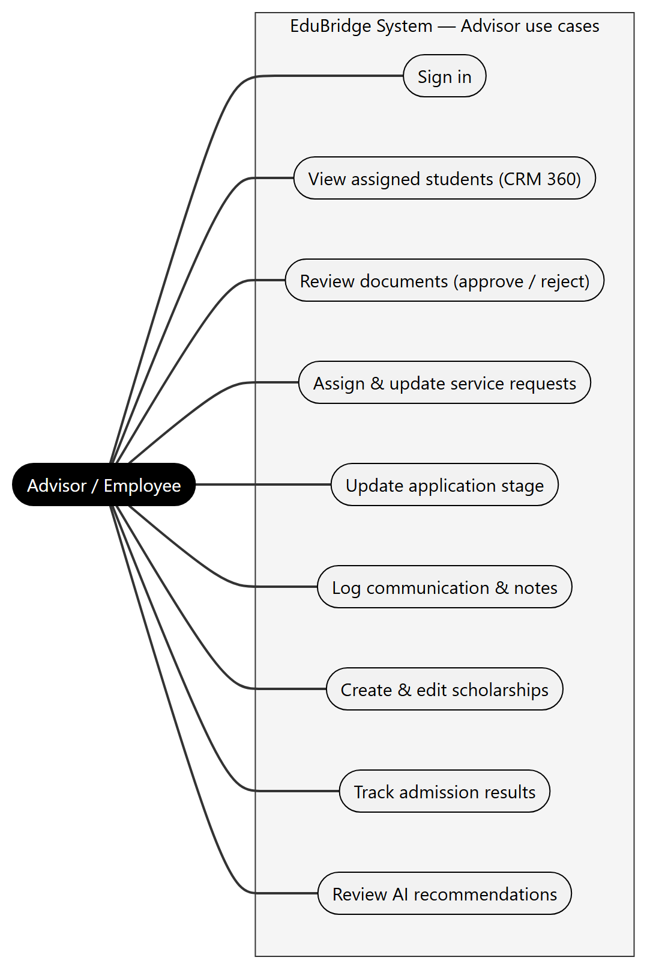
Figure 3: Use case diagram — Advisor / Employee
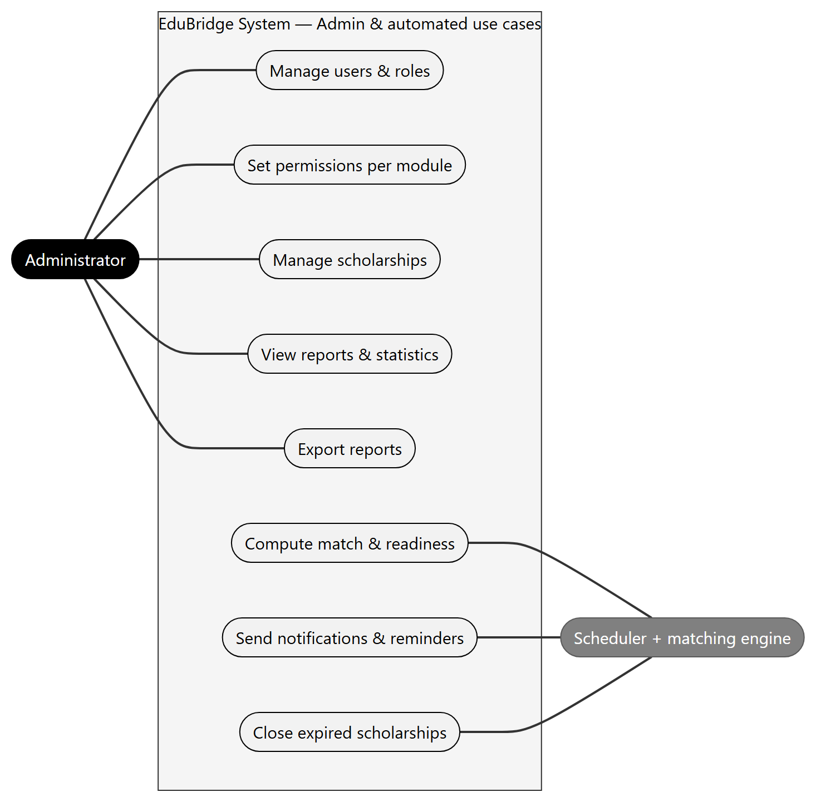
Figure 4: Use case diagram — Administrator and automated system

4.1 Use case descriptions
Table 8: Use case UC-01
Field | UC-01 Register a student account
Actor | Student (visitor)
Pre-condition | The email address is not registered.
Main flow | 1. Visitor opens sign-up. 2. Enters account, personal, academic and goal data (5 steps). 3. Reviews and confirms. 4. System creates users and students rows in one transaction. 5. System sends a confirmation email and computes the first recommendations.
Alternative | Email already used → 409 email_taken; invalid data → 422 with the failing fields.
Post-condition | Student is signed in and sees the dashboard.

Table 9: Use case UC-04
Field | UC-04 Upload a document
Actor | Student
Pre-condition | Student is signed in.
Main flow | 1. Student selects the document type and file. 2. System checks the size (≤ 10 MB) and the MIME type from the file content. 3. File is stored with a random name outside the public folder. 4. A documents row is created with status underReview. 5. Readiness score is recomputed.
Alternative | Unsupported type or too large → 422 validation_failed.
Post-condition | Advisor is notified to review the document.

Table 10: Use case UC-13
Field | UC-13 Update application stage
Actor | Advisor
Pre-condition | The application exists and is assigned to the advisor.
Main flow | 1. Advisor opens Student 360. 2. Selects the next stage. 3. System updates applications.stage and inserts a row in application_stage_history. 4. Student is notified.
Alternative | Final stage → advisor records the result (accepted / rejected).
Post-condition | Timeline and reports are updated.

Traceability
Each use case maps to API endpoints (Section 10) and to database tables (Section 9), so every requirement can be followed from the interface to the data.

5. Class Diagrams

5.1 Domain model
The domain model shows the business objects and their relationships. Student, Employee and Administrator specialise User (generalisation). In the database this is implemented as one users table plus a students table in a one-to-one relationship, because only students have academic data.
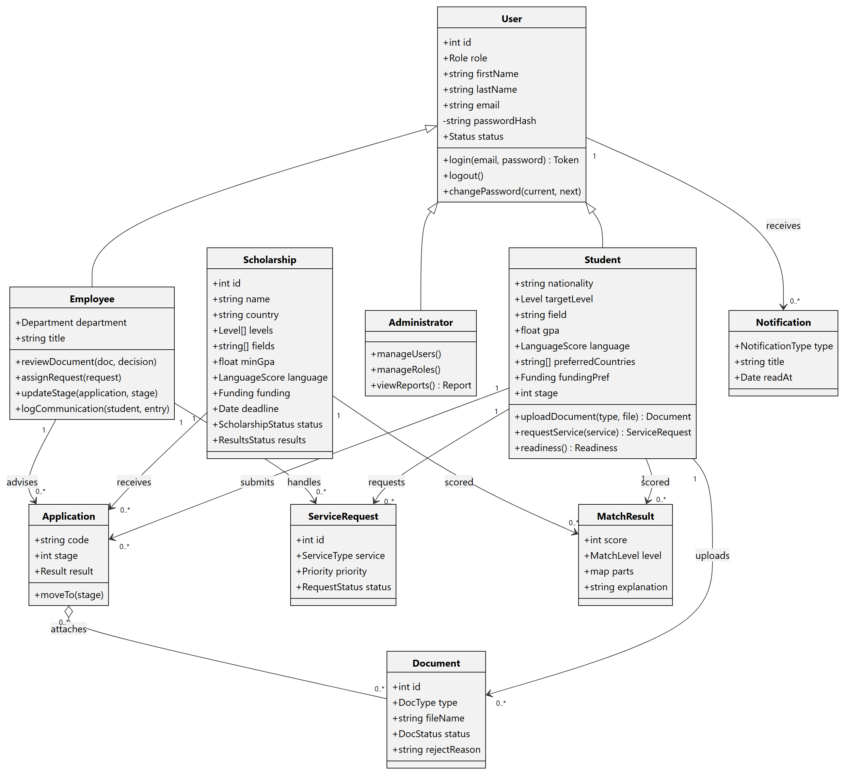
Figure 5: Domain class diagram

5.2 Back-end design classes
The PHP API is organised in three layers: Core (router, request/response, JWT, authentication, validation, database), Services (matching, mapping) and Controllers (one per resource). Static helpers keep the code small and easy to read for the team.
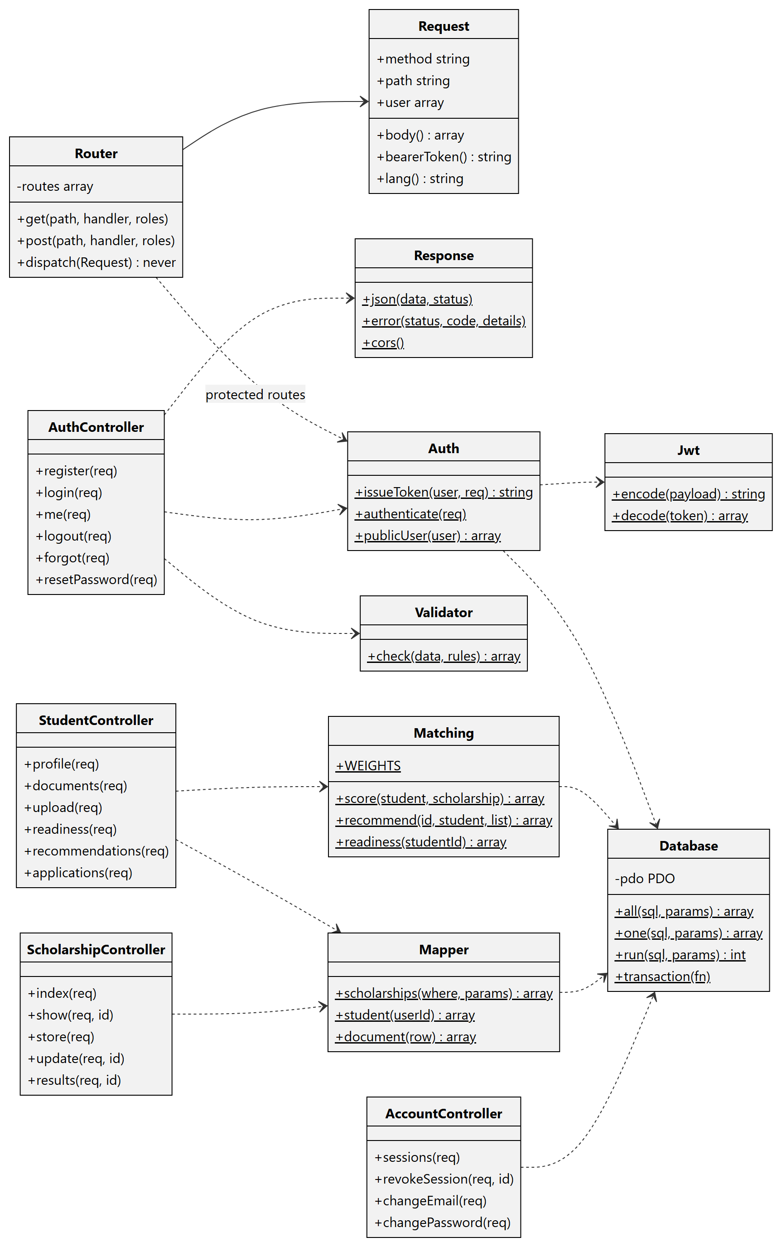
Figure 6: Back-end class diagram (PHP API)
Table 11: Back-end classes
Class | Responsibility
Router | Matches method + path, enforces the roles of protected routes, calls the controller.
Auth / Jwt | Issues signed tokens, stores one session per device, verifies and revokes tokens.
Database | Single PDO connection; all, one, run and transaction with prepared statements.
Validator | Rule-based validation (required, email, min, max, numeric, between, in, date).
Matching | Weighted match score, classification and readiness score; caches results.
Mapper | Converts database rows (snake_case) to the JSON used by React (camelCase).

6. Sequence Diagrams

6.1 Sign in
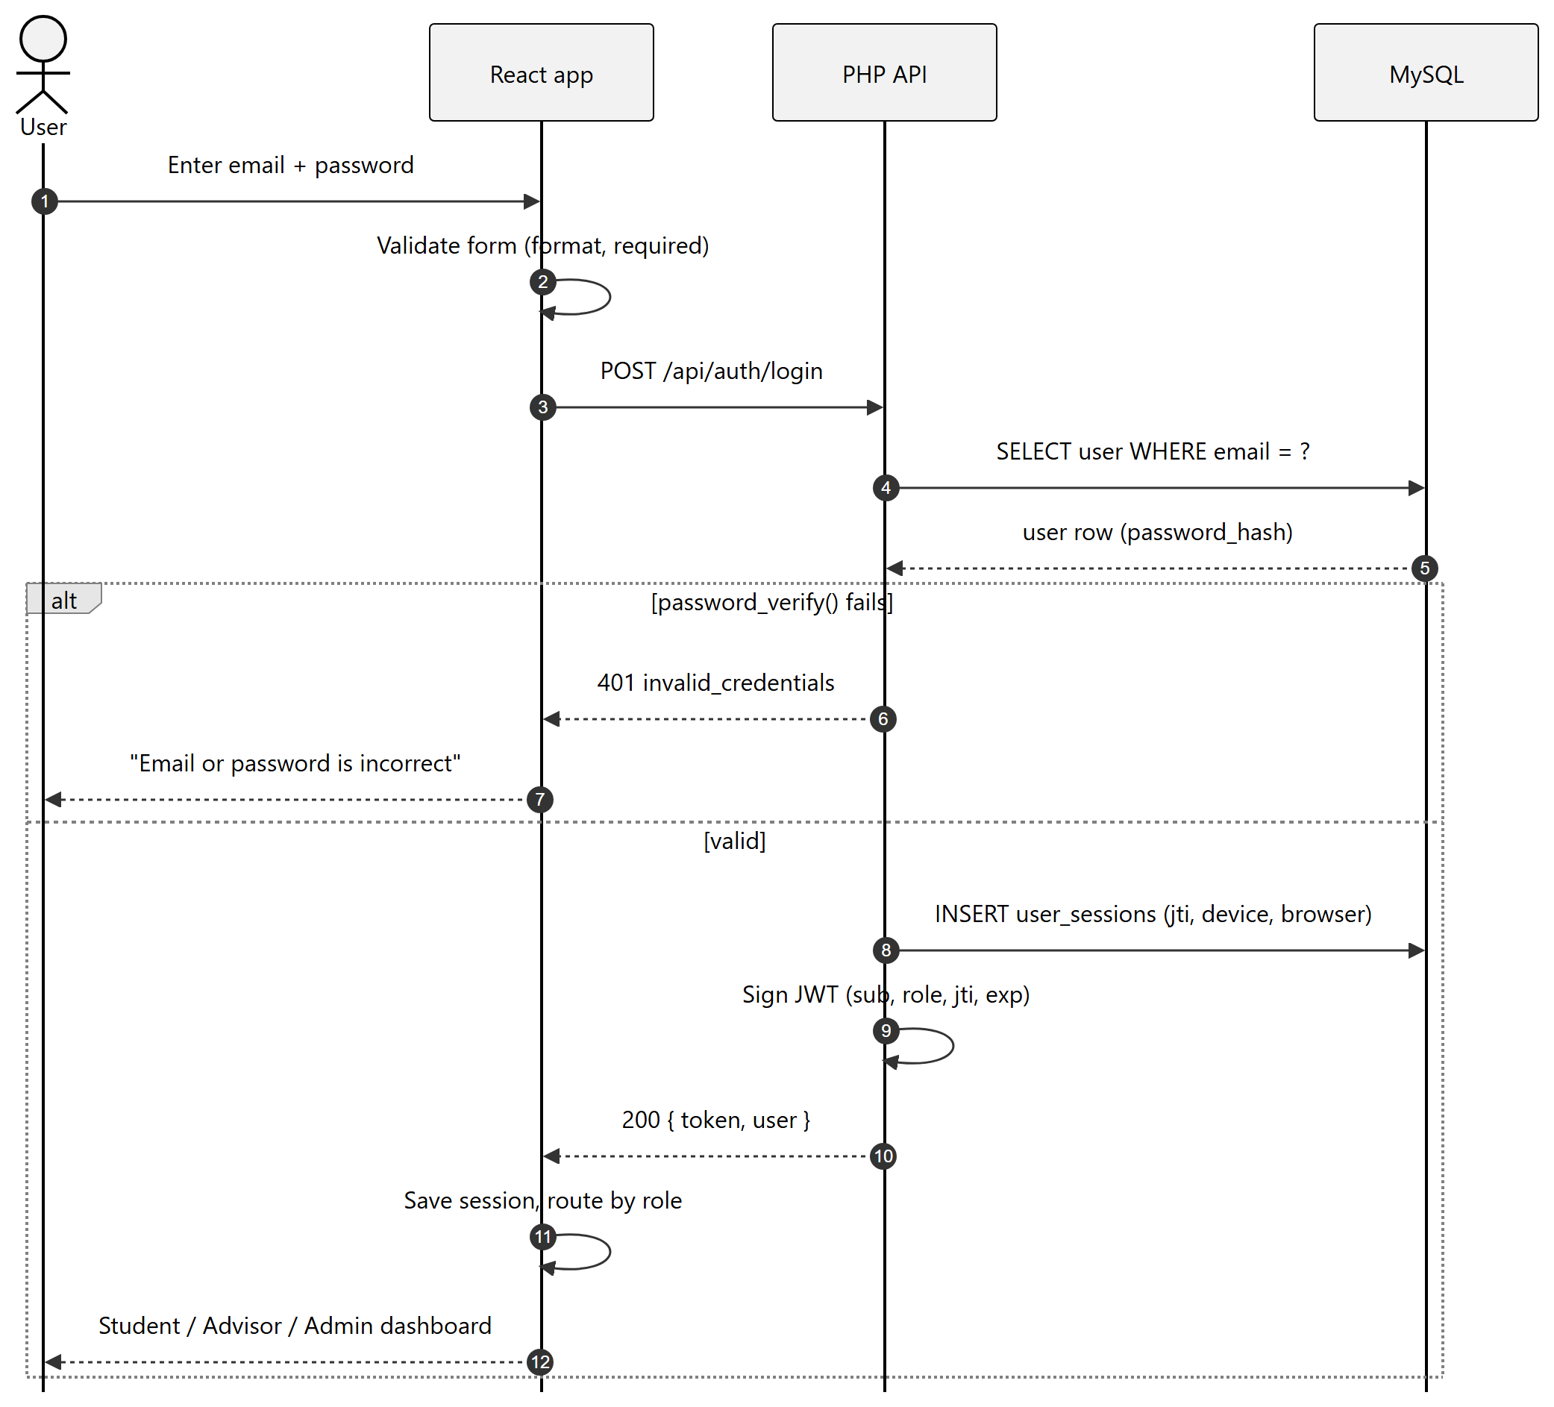
Figure 7: Sequence diagram — sign in

6.2 Upload a document and update readiness
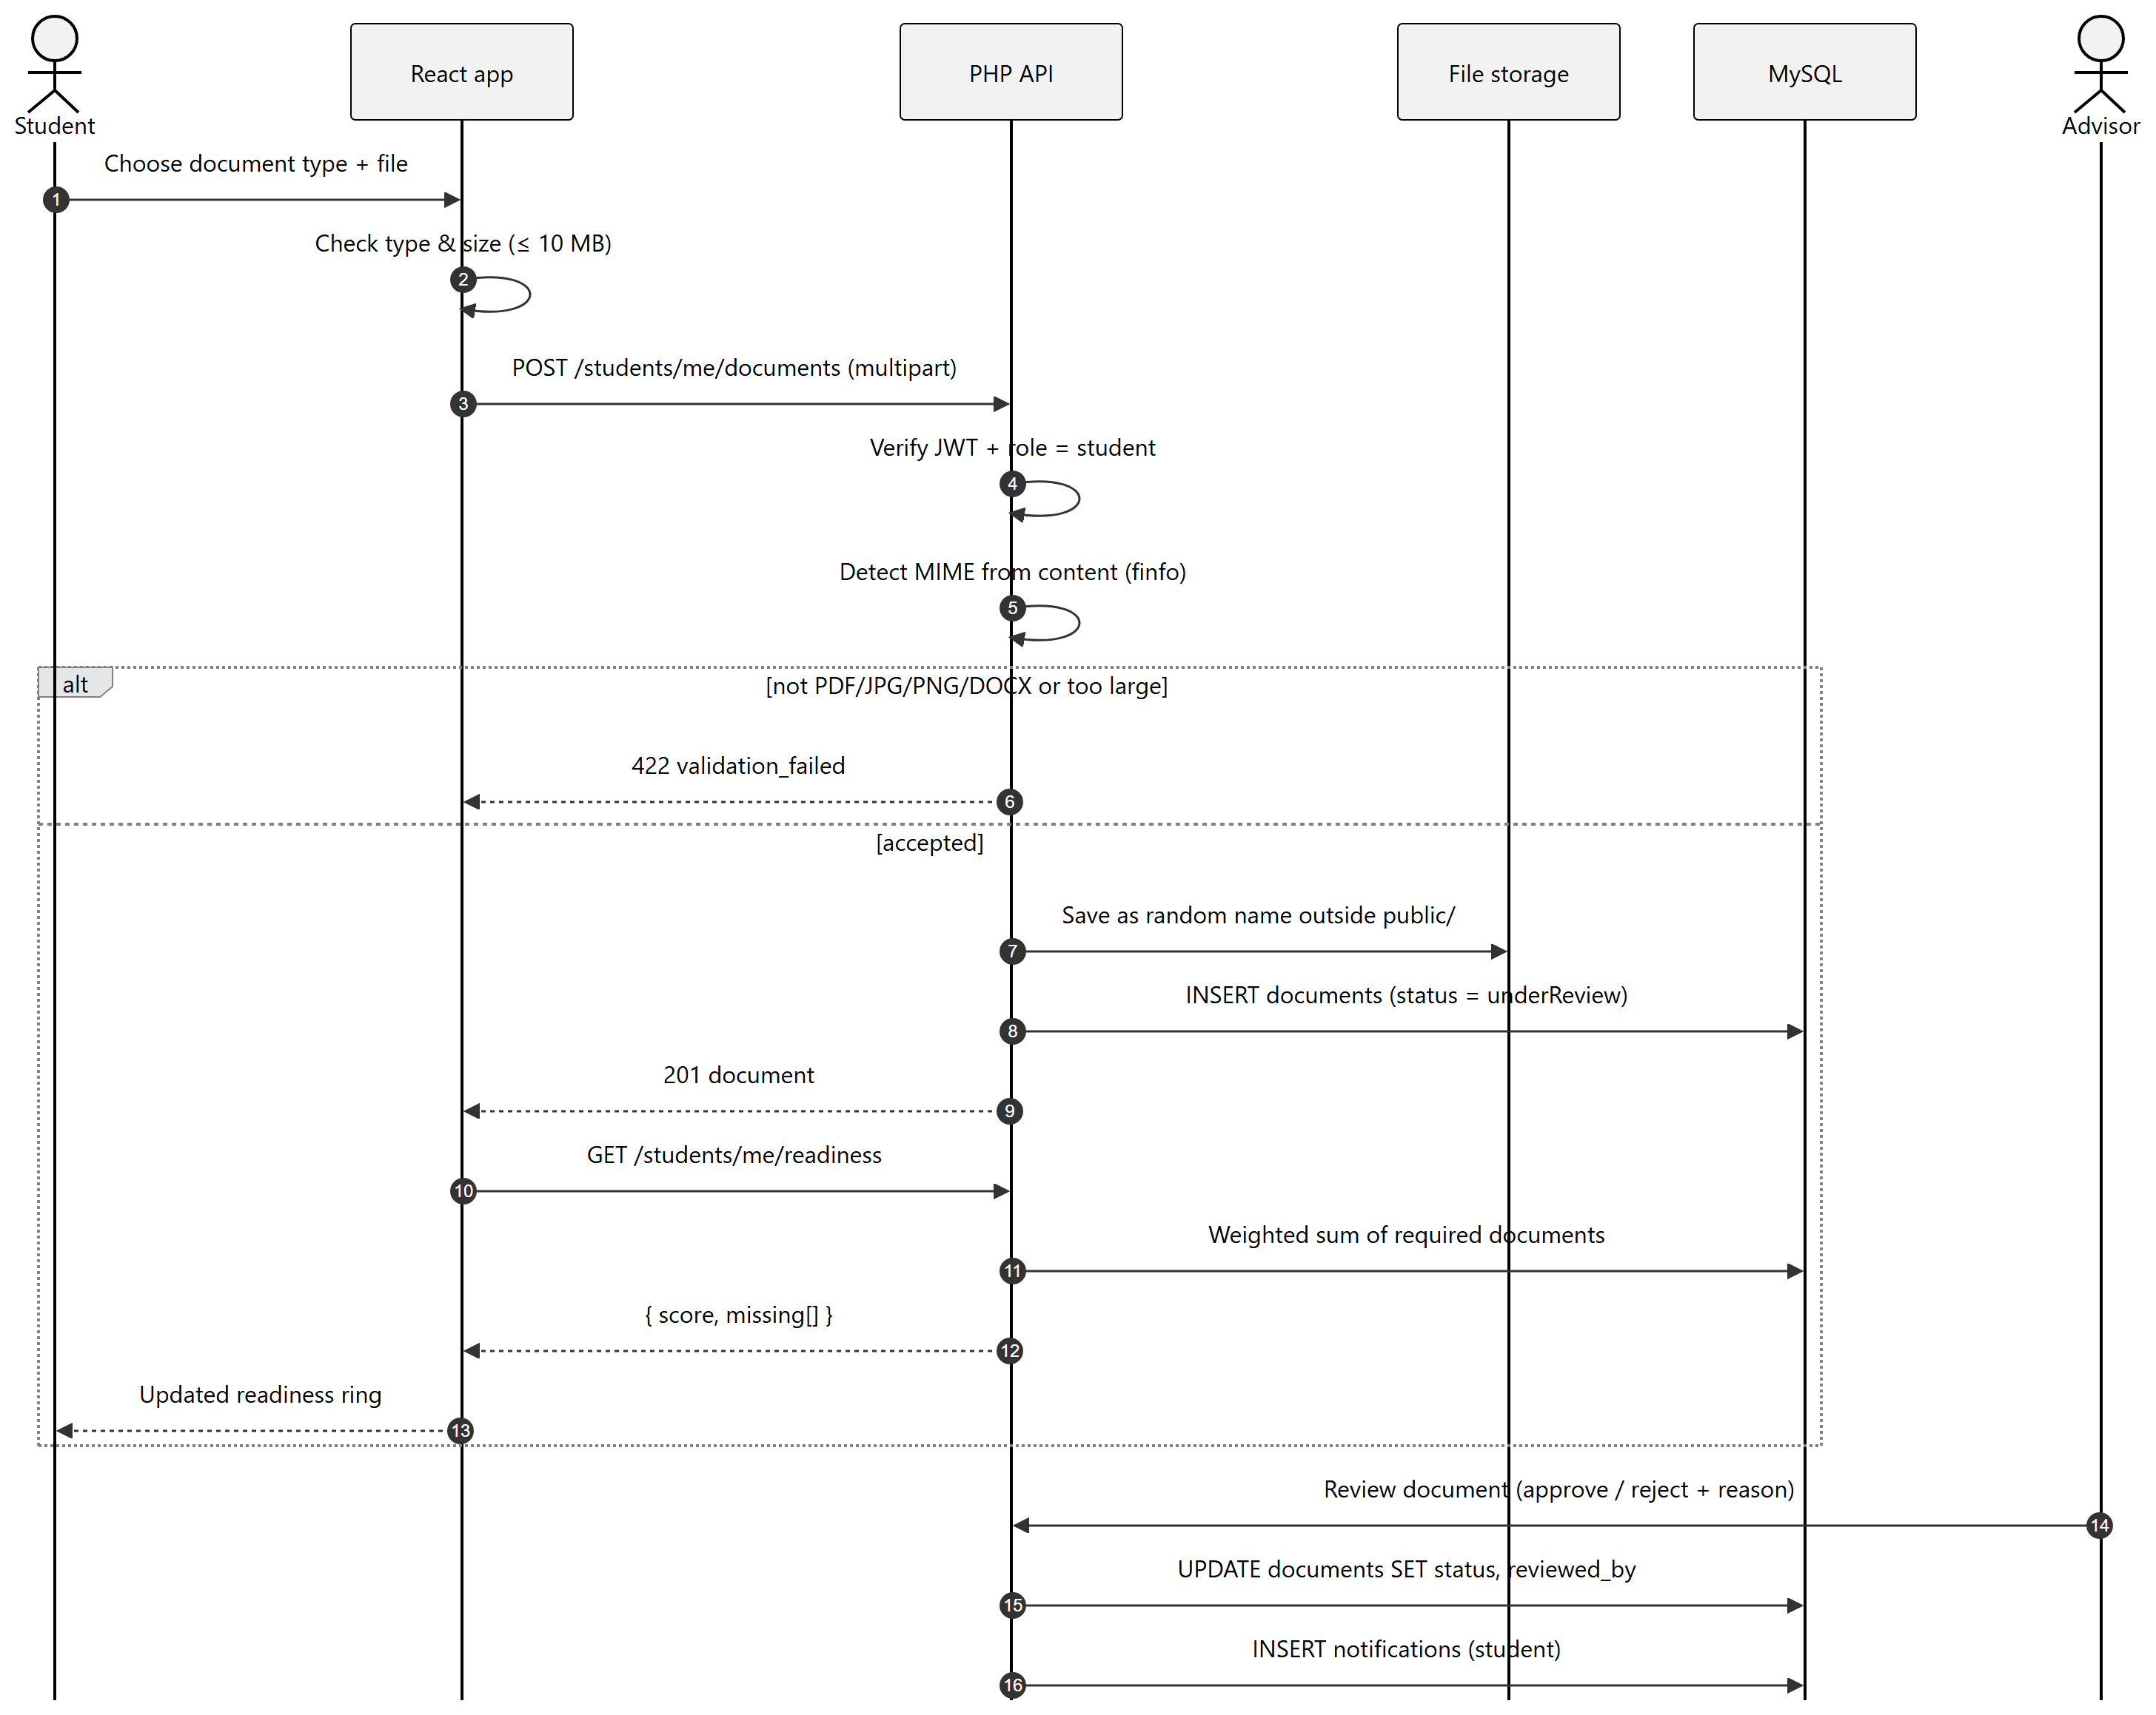
Figure 8: Sequence diagram — document upload and review

6.3 Service request handled by an advisor
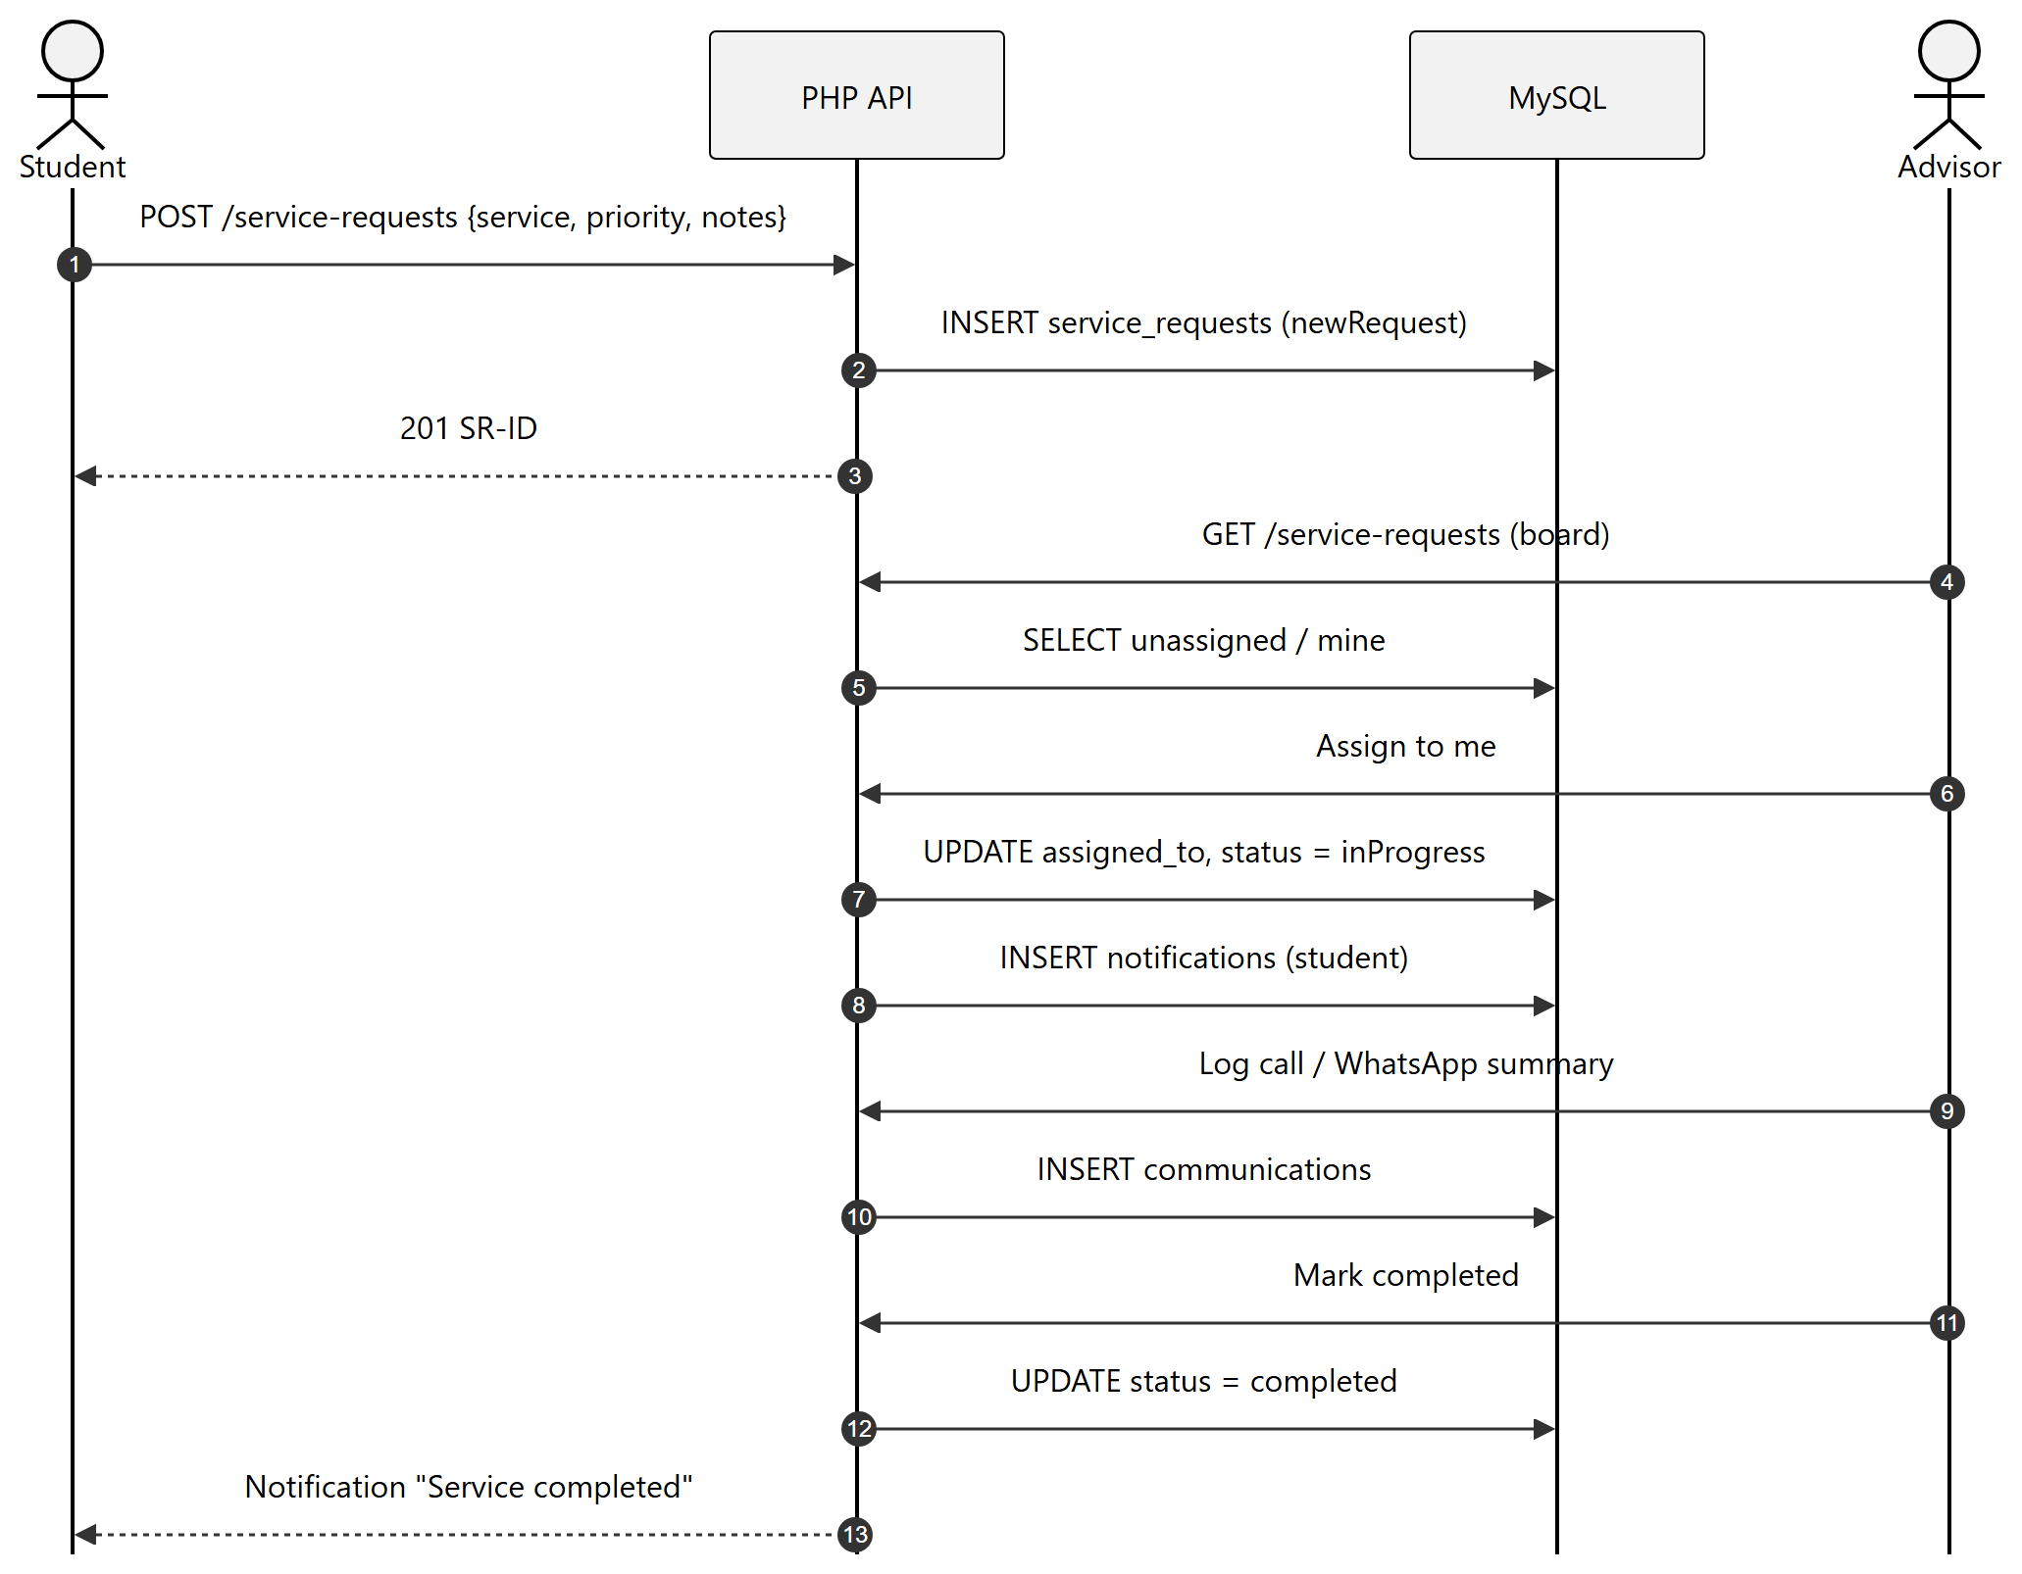
Figure 9: Sequence diagram — service request

7. Activity Diagrams

7.1 Student registration
Registration is split into five short steps to reduce errors. Each step is validated before moving on, and the account is created in one database transaction at the end.
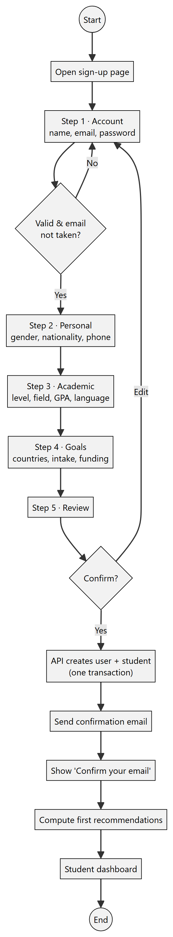
Figure 10: Activity diagram — student registration

7.2 Scholarship application journey
Each activity starts with the actor who performs it: Student, Advisor or System.
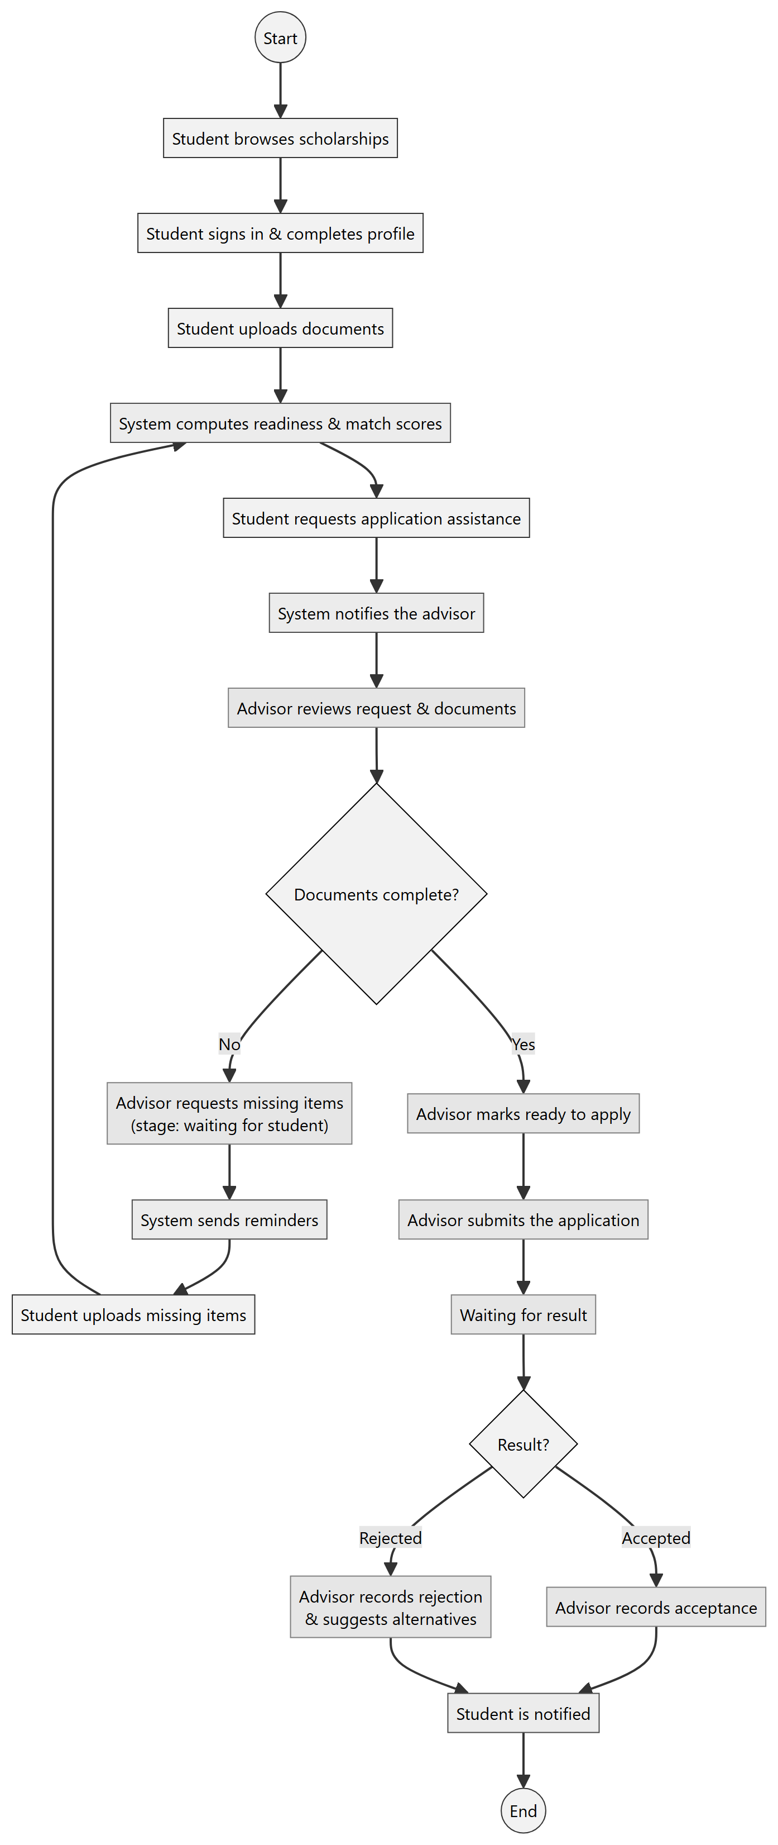
Figure 11: Activity diagram — end-to-end application journey

8. State Diagrams
State diagrams define the allowed status values stored in the database (ENUM columns) and the transitions the API accepts.

8.1 Application (8 stages)
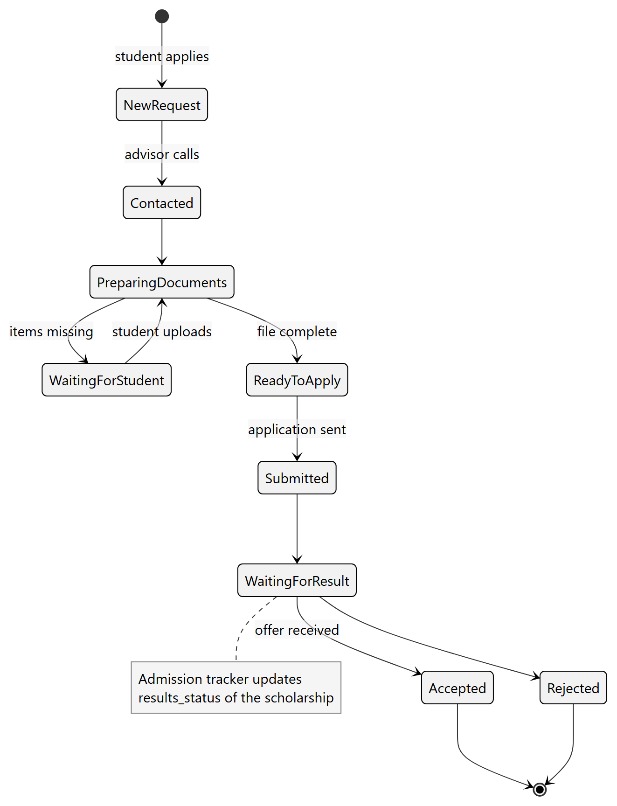
Figure 12: State diagram — application
Table 12: Application stages
Stage | Value in applications.stage | Meaning
New request | 0 | Student asked for help with this scholarship.
Contacted | 1 | Advisor made the first contact.
Preparing documents | 2 | File is being prepared.
Waiting for student | 3 | Something is missing from the student.
Ready to apply | 4 | File is complete.
Submitted | 5 | Application sent to the provider.
Waiting for result | 6 | Waiting for the decision.
Accepted / Rejected | 7 + result | Final decision recorded.

8.2 Document
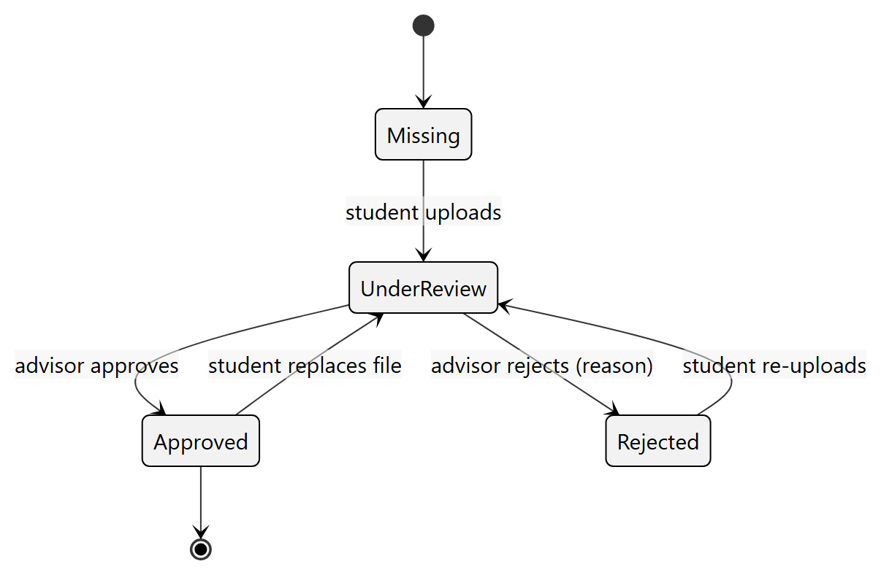
Figure 13: State diagram — document review

8.3 Service request
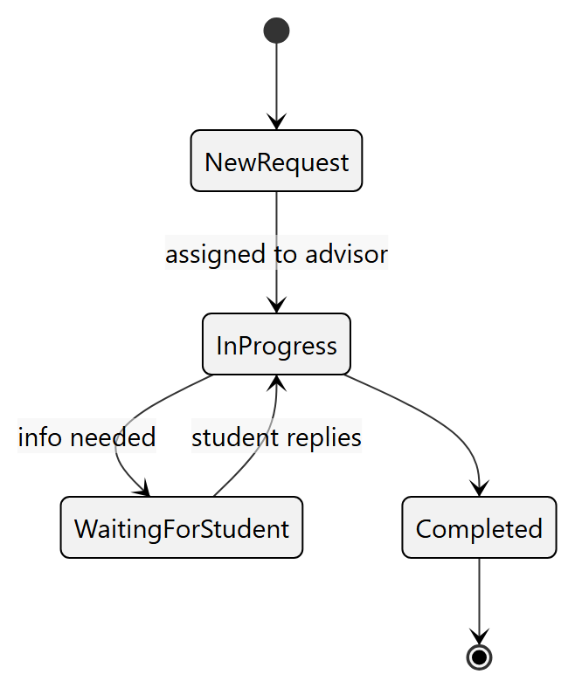
Figure 14: State diagram — service request

8.4 Scholarship and admission results
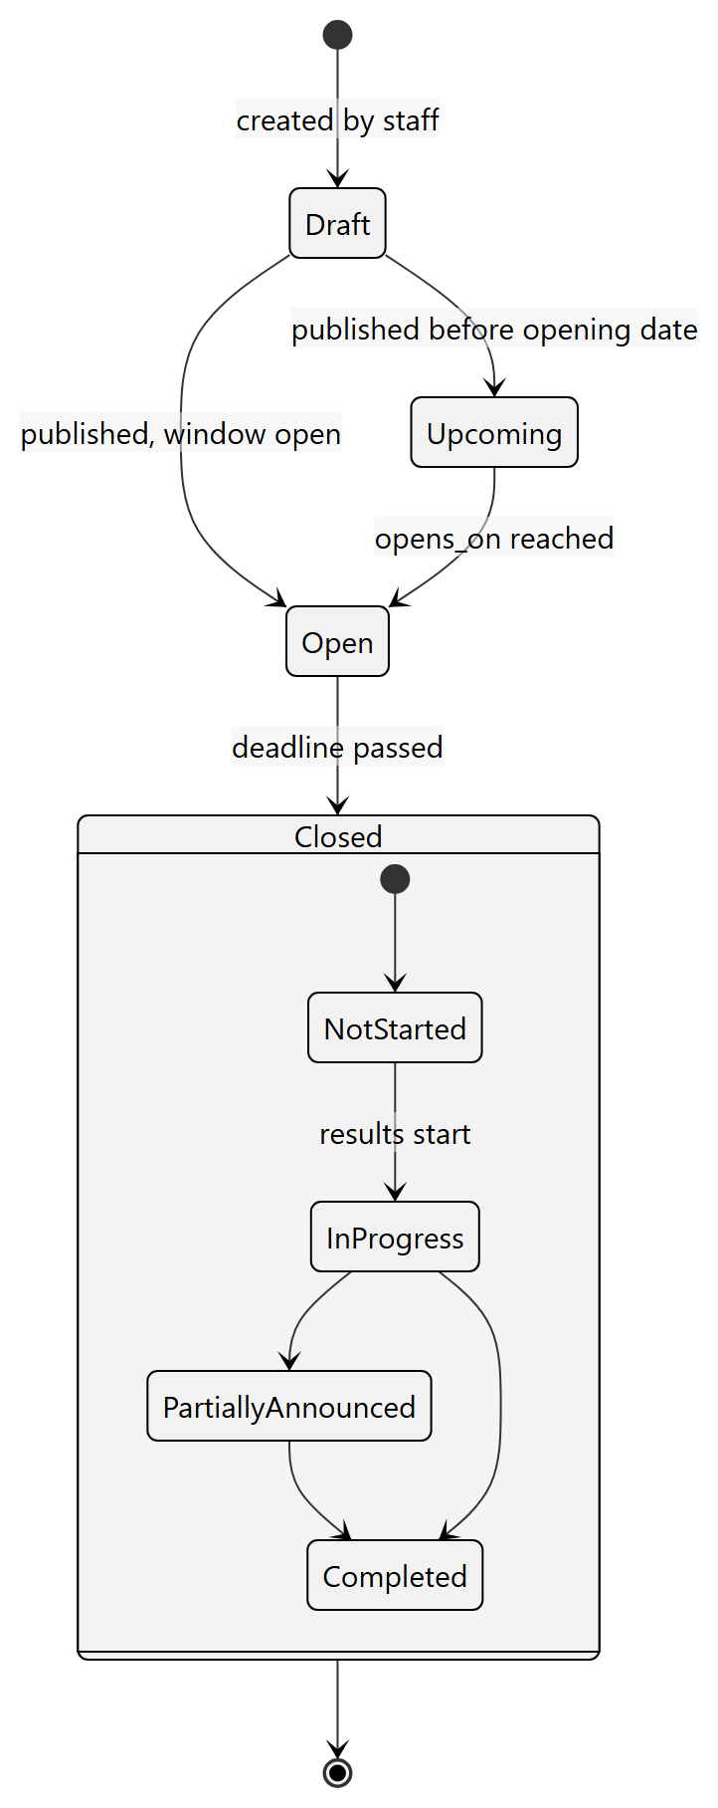
Figure 15: State diagram — scholarship window and results

8.5 User account
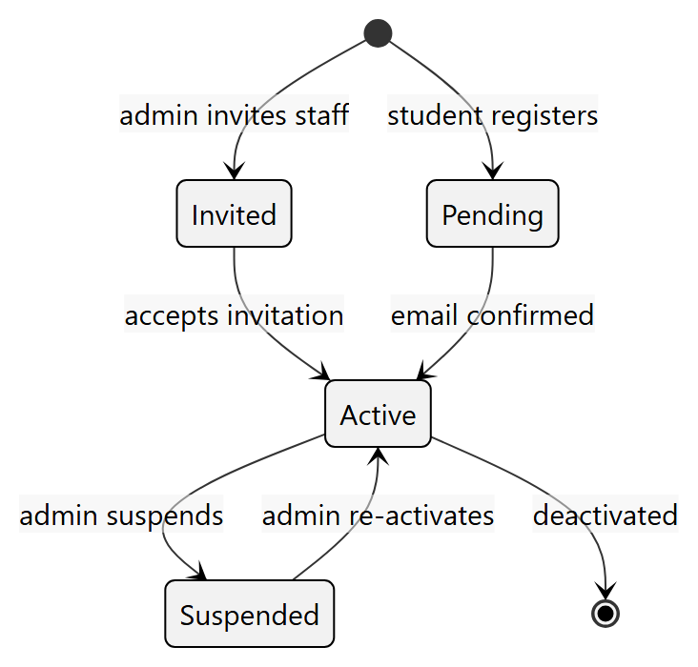
Figure 16: State diagram — user account

9. Database Design

9.1 Design approach
The database was designed top-down: entities were taken from the proposal modules, refined into a conceptual ERD, then into a logical relational model in third normal form (3NF), and finally implemented in MySQL with InnoDB (transactions + foreign keys) and the utf8mb4 character set so that Arabic and English text are stored correctly.
Table 13: Main design decisions
Decision | Reason
One users table for all roles + students (1 : 0..1) | Shared login and security for every role; only students have academic data.
Multi-valued attributes in their own tables | Levels, fields, nationalities and preferred countries need many values per row (1NF).
ENUM for fixed status values | The state diagrams define a closed set of values; ENUM rejects invalid data.
match_scores as a cache table | Scores are expensive to recompute on every page; they are refreshed when inputs change.
History tables (application_stage_history, audit_log) | Full traceability of who changed what and when.
Files on disk, metadata in MySQL | Keeps the database small; paths are not public.

9.2 Conceptual ERD
The overview shows the main entities and their relationships. Link tables are shown in the detailed ERDs that follow.
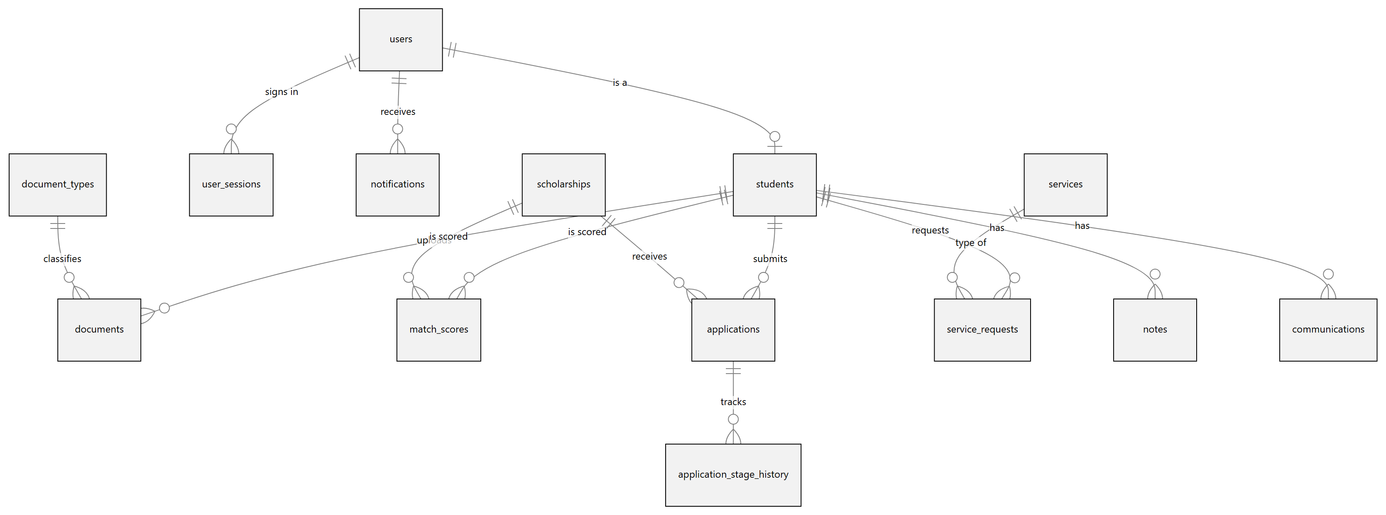
Figure 17: Conceptual ERD (main entities)

9.3 Logical ERDs by module
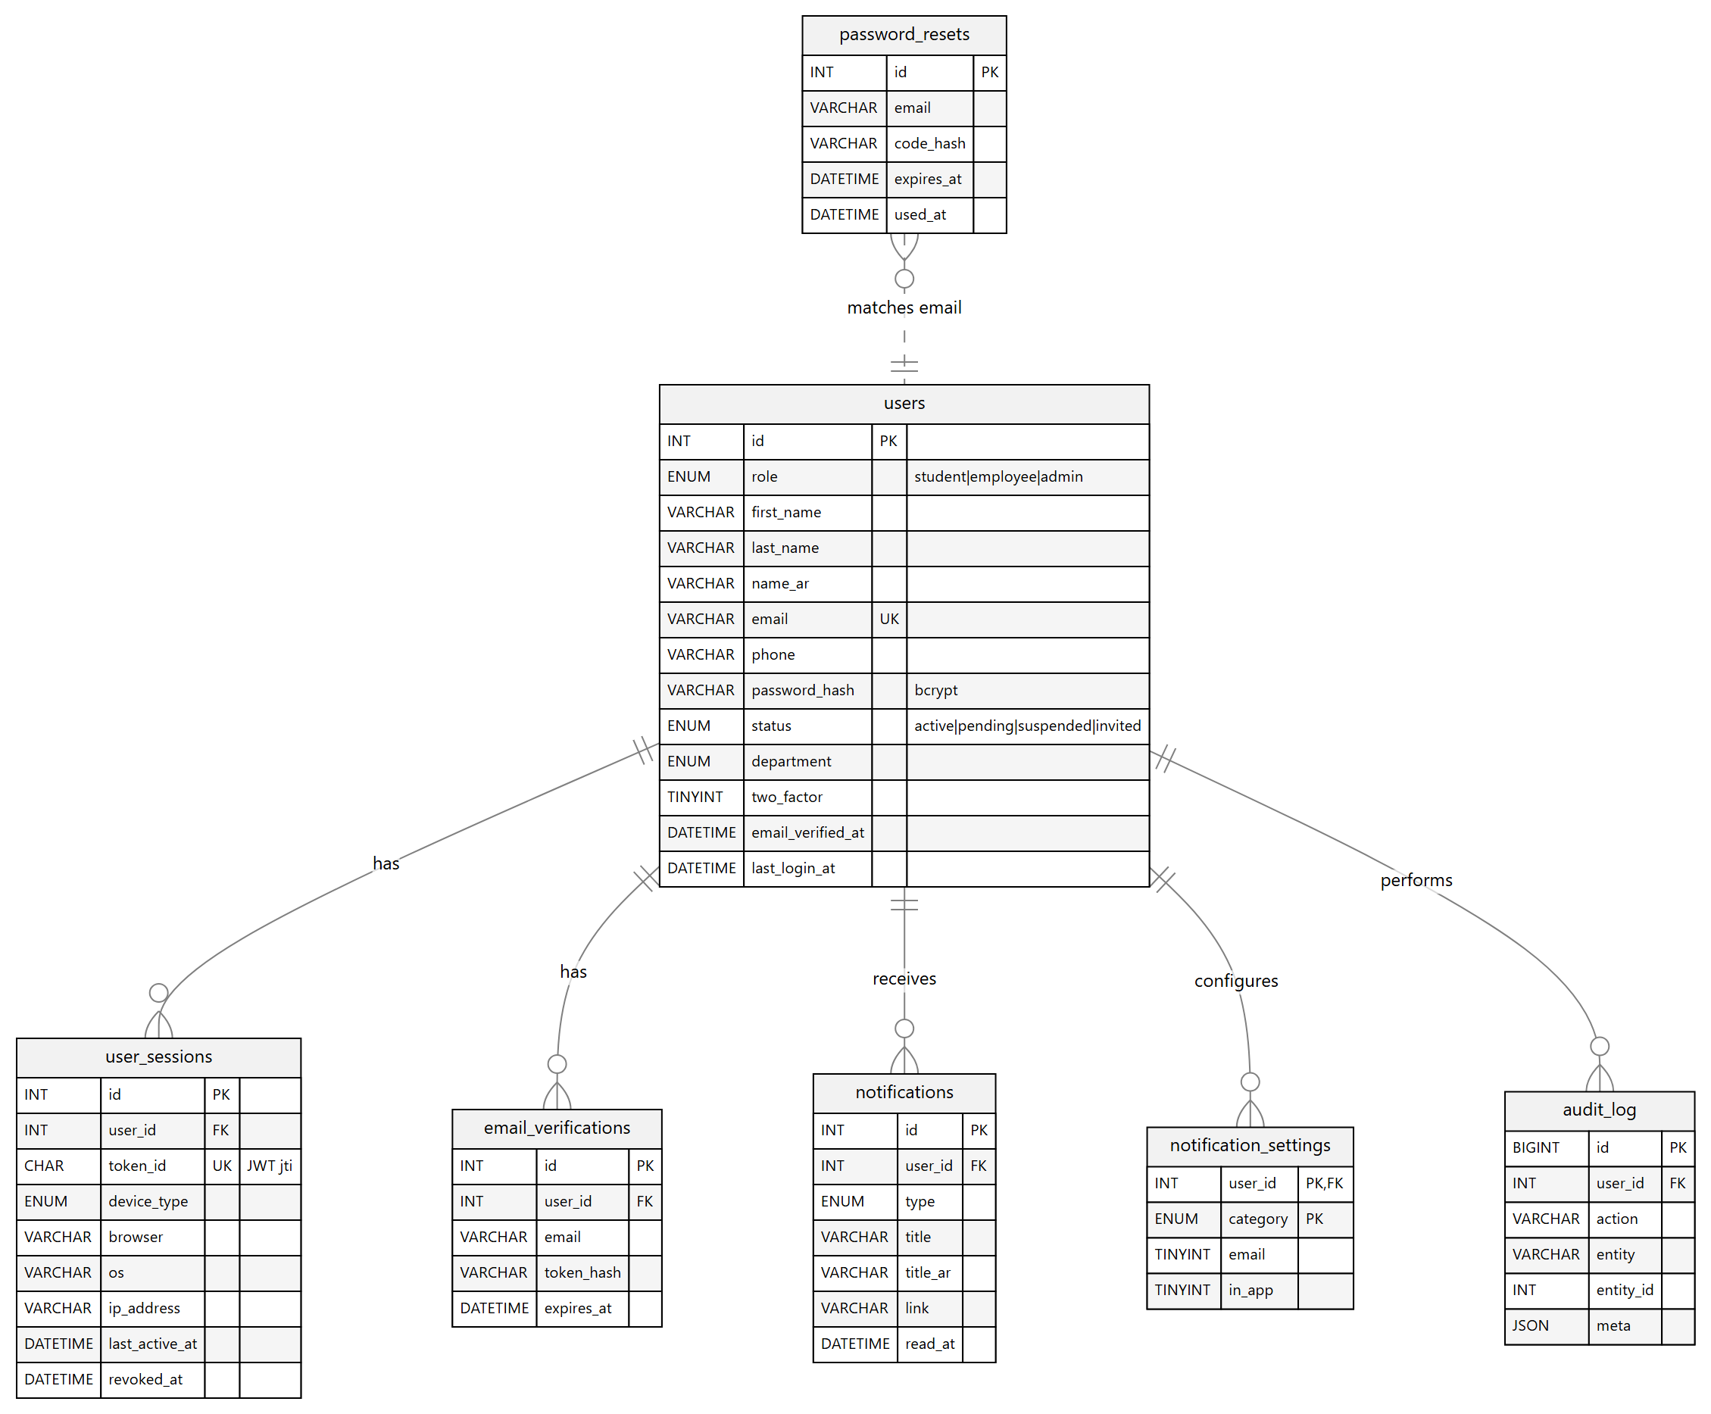
Figure 18: ERD — users, authentication and notifications
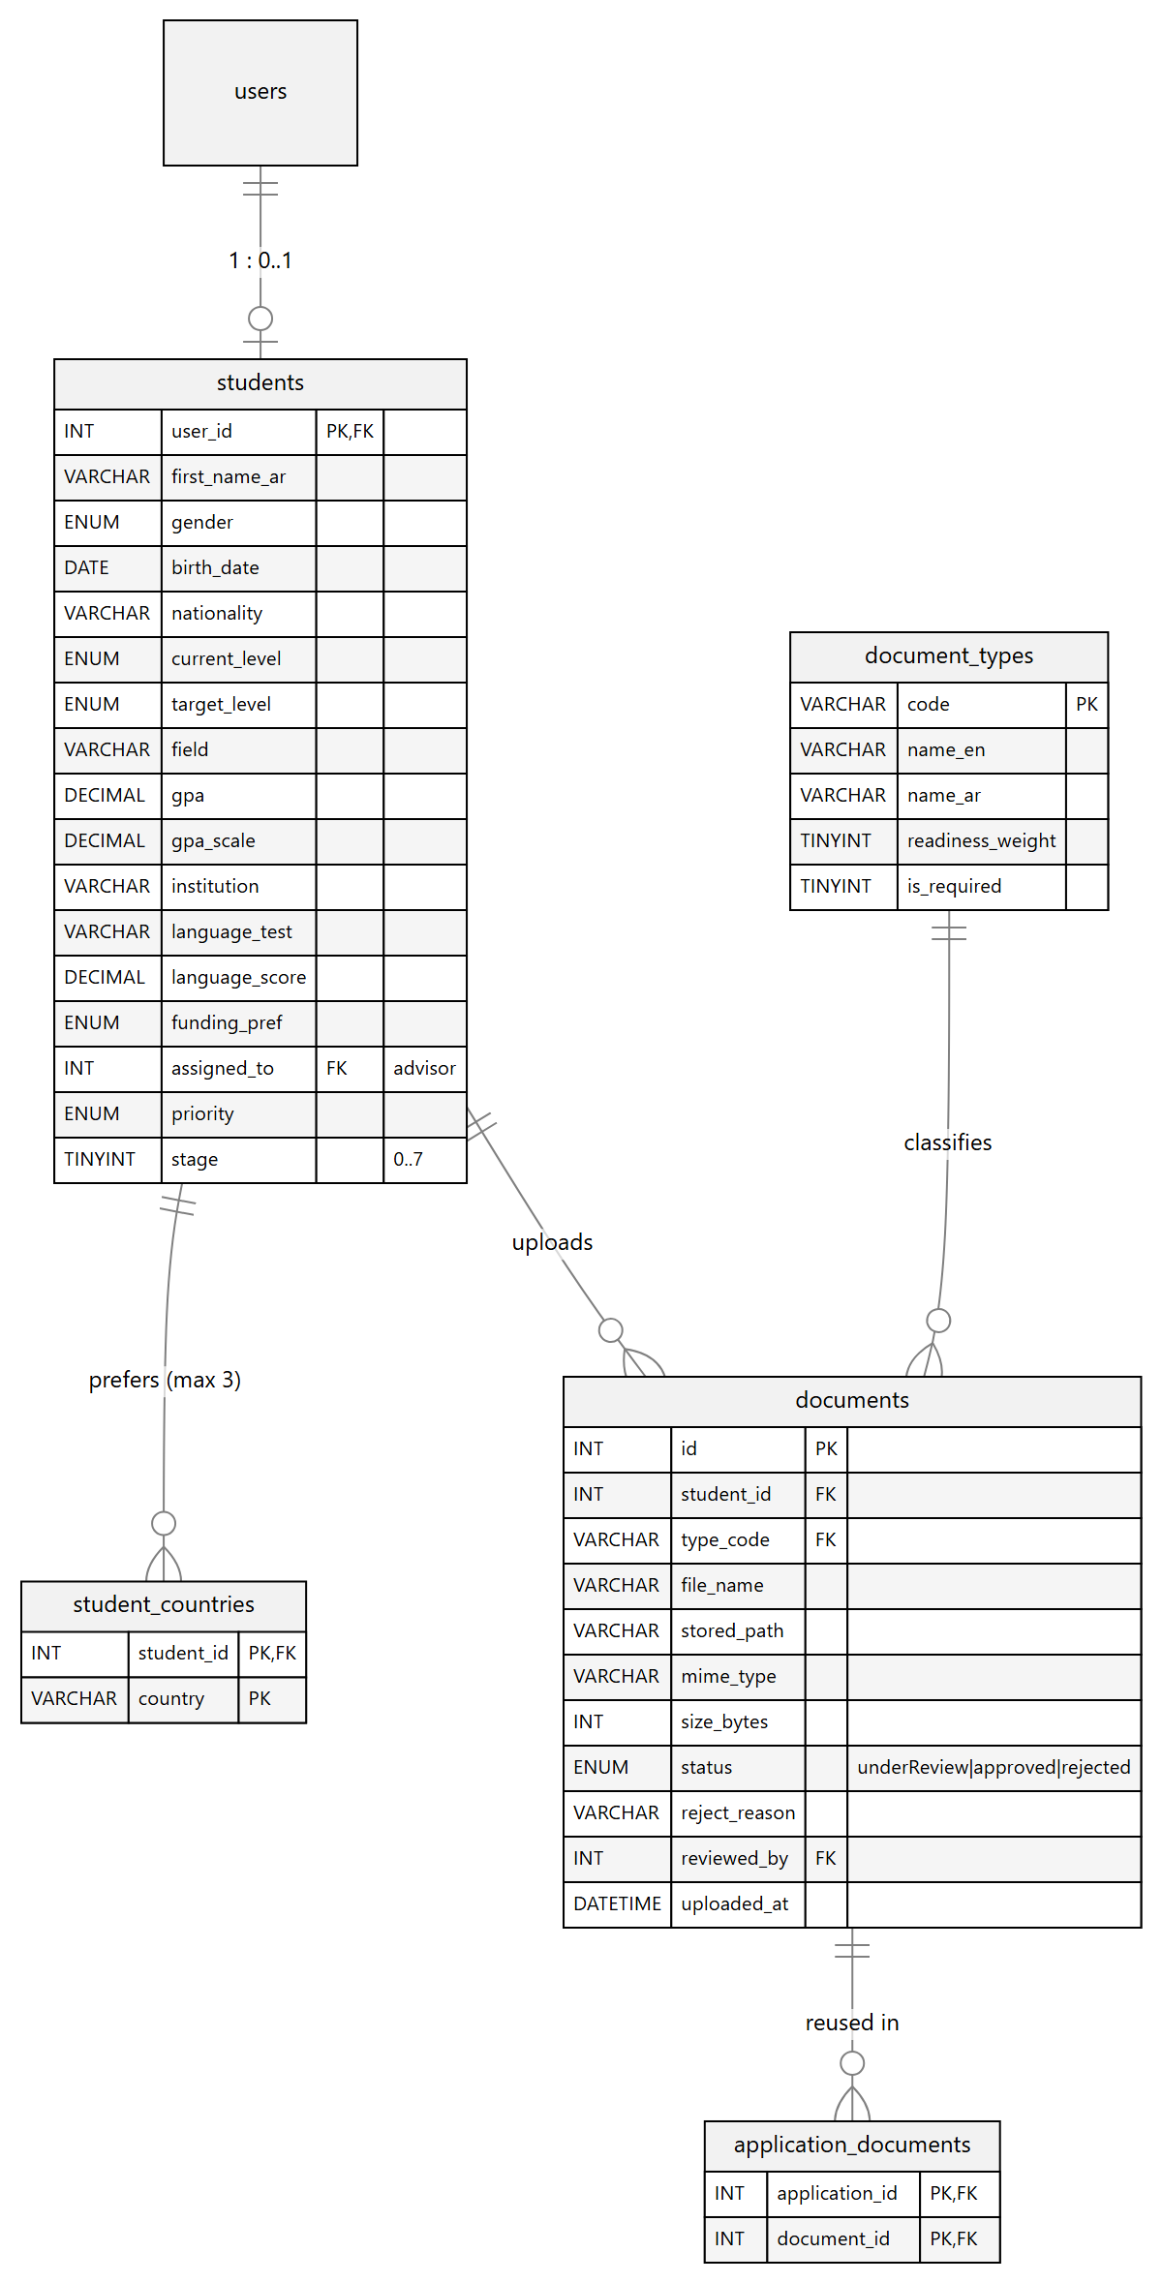
Figure 19: ERD — students and documents
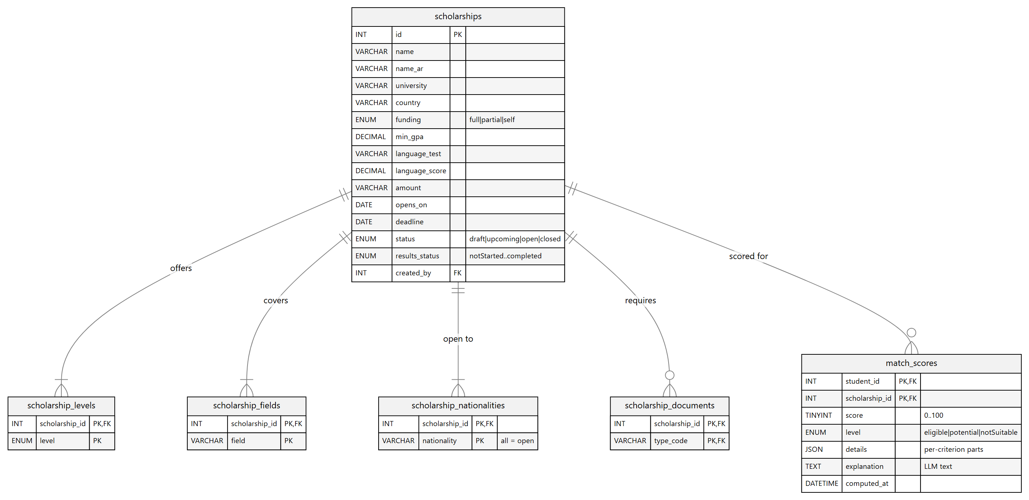
Figure 20: ERD — scholarships and match results
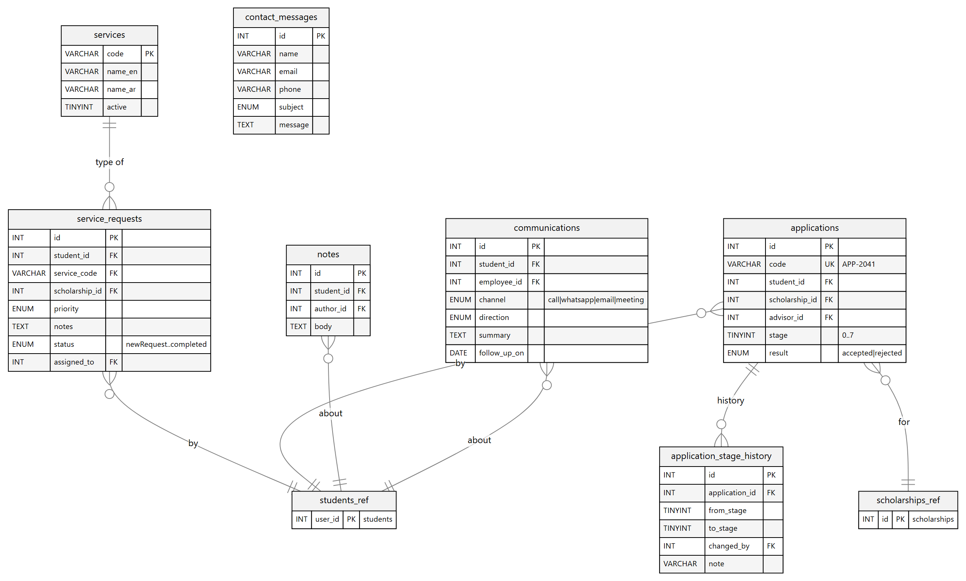
Figure 21: ERD — services, applications and CRM

9.4 Normalisation
- 1NF — every column holds one atomic value. Repeating groups (study levels, fields, nationalities, preferred countries) were moved to their own tables, e.g. scholarship_levels(scholarship_id, level).
- 2NF — tables with composite keys (student_countries, scholarship_fields, match_scores, notification_settings) contain no attribute that depends on only part of the key.
- 3NF — no transitive dependencies: document type names live in document_types, service names in services, and only codes are stored in documents and service_requests.
- Controlled redundancy — match_scores stores computed values on purpose (caching) and can be rebuilt at any time from the source tables.

9.5 Keys, constraints and indexes
Table 14: Integrity rules
Rule | Where | Purpose
Primary keys | Every table (AUTO_INCREMENT or composite) | Unique row identity
34 foreign keys | ON DELETE CASCADE for owned data, SET NULL for staff references | Referential integrity
UNIQUE | users.email, user_sessions.token_id, applications.code, (student, scholarship) | No duplicates
CHECK | stage BETWEEN 0 AND 7 | Valid workflow stage
Indexes | users(role,status), scholarships(status,country,deadline), documents(student_id,type_code) … | Fast filtering and dashboards

9.6 Data dictionary
The dictionary below is generated directly from database/schema.sql, so it always matches the real database: 25 tables and 199 columns.

9.6.1 Users & authentication
users — Every account (student, advisor/employee, administrator) with credentials and status.
Column | Type | Null | Key | Default | Description
id | INT UNSIGNED | No | PK |  | Primary key (auto increment)
role | ENUM('student', 'employee', 'admin') | No |  | student | Access role
first_name | VARCHAR(80) | No |  |  | First name
last_name | VARCHAR(80) | No |  |  | Last name
name_ar | VARCHAR(160) | Yes |  |  | Full name in Arabic
email | VARCHAR(190) | No | UK |  | Email address (lower-case)
phone | VARCHAR(30) | Yes |  |  | Phone
password_hash | VARCHAR(255) | No |  |  | bcrypt hash of the password — never the plain password
status | ENUM('active', 'pending', 'suspended', 'invited') | No |  | active | Current status
department | ENUM('studentServices', 'admissions', 'visa', 'scholarships', 'compliance') | Yes |  |  | Staff department
title | VARCHAR(80) | Yes |  |  | Title
title_ar | VARCHAR(80) | Yes |  |  | Arabic version of title
avatar_path | VARCHAR(255) | Yes |  |  | Avatar path
two_factor | TINYINT(1) | No |  | 0 | 2-step verification enabled
login_alerts | TINYINT(1) | No |  | 1 | Email on new device sign-in
email_verified_at | DATETIME | Yes |  |  | Email confirmation time
last_login_at | DATETIME | Yes |  |  | Last successful sign-in
created_at | DATETIME | No |  | CURRENT_TIMESTAMP | Creation time
updated_at | DATETIME | No |  | CURRENT_TIMESTAMP ON UPDATE CURRENT_TIMESTAMP | Last update time (auto)

user_sessions — One row per signed-in device; the JWT id (jti) lets a device be signed out remotely.
Column | Type | Null | Key | Default | Description
id | INT UNSIGNED | No | PK |  | Primary key (auto increment)
user_id | INT UNSIGNED | No | FK |  | References users.id
token_id | CHAR(32) | No | UK |  | JWT id (jti) of the issued token
device_type | ENUM('laptop', 'phone', 'tablet') | No |  | laptop | laptop | phone | tablet
browser | VARCHAR(60) | Yes |  |  | Browser
os | VARCHAR(60) | Yes |  |  | Os
ip_address | VARCHAR(45) | Yes |  |  | IPv4/IPv6 address
city | VARCHAR(80) | Yes |  |  | City
created_at | DATETIME | No |  | CURRENT_TIMESTAMP | Creation time
last_active_at | DATETIME | No |  | CURRENT_TIMESTAMP | Last request from this device
revoked_at | DATETIME | Yes |  |  | Set when the device is signed out

password_resets — Hashed 6-digit reset codes with a 10-minute expiry.
Column | Type | Null | Key | Default | Description
id | INT UNSIGNED | No | PK |  | Primary key (auto increment)
email | VARCHAR(190) | No |  |  | Email address (lower-case)
code_hash | VARCHAR(255) | No |  |  | Code hash
expires_at | DATETIME | No |  |  | Expiry time
used_at | DATETIME | Yes |  |  | When the code/token was used
created_at | DATETIME | No |  | CURRENT_TIMESTAMP | Creation time

email_verifications — Pending email confirmations (sign-up and email change).
Column | Type | Null | Key | Default | Description
id | INT UNSIGNED | No | PK |  | Primary key (auto increment)
user_id | INT UNSIGNED | No | FK |  | References users.id
email | VARCHAR(190) | No |  |  | Email address (lower-case)
token_hash | VARCHAR(255) | No |  |  | Token hash
expires_at | DATETIME | No |  |  | Expiry time
used_at | DATETIME | Yes |  |  | When the code/token was used
created_at | DATETIME | No |  | CURRENT_TIMESTAMP | Creation time

9.6.2 Students & documents
students — Academic and personal profile of a student (1 : 0..1 with users).
Column | Type | Null | Key | Default | Description
user_id | INT UNSIGNED | No | PK, FK |  | References users.id
first_name_ar | VARCHAR(80) | Yes |  |  | Arabic version of first name
last_name_ar | VARCHAR(80) | Yes |  |  | Arabic version of last name
gender | ENUM('female', 'male') | Yes |  |  | Gender
birth_date | DATE | Yes |  |  | Birth date
nationality | VARCHAR(30) | Yes |  |  | Country code of nationality
country | VARCHAR(30) | Yes |  |  | Country code
city | VARCHAR(80) | Yes |  |  | City
current_level | ENUM('highSchool', 'bachelor', 'master') | Yes |  |  | Current level
target_level | ENUM('bachelor', 'master', 'phd') | Yes |  |  | Target level
field | VARCHAR(40) | Yes |  |  | Academic field code
gpa | DECIMAL(5,2) | Yes |  |  | Grade point average
gpa_scale | DECIMAL(5,2) | No |  | 4.00 | Maximum of the GPA scale (4 or 100)
institution | VARCHAR(160) | Yes |  |  | Institution
institution_ar | VARCHAR(160) | Yes |  |  | Arabic version of institution
graduation_year | SMALLINT | Yes |  |  | Graduation year
language_test | VARCHAR(20) | Yes |  |  | IELTS, TOEFL …
language_score | DECIMAL(5,1) | Yes |  |  | Test score (e.g. IELTS 6.5)
funding_pref | ENUM('full', 'partial', 'self') | Yes |  |  | Preferred funding type
intake | VARCHAR(40) | Yes |  |  | Intake
help_level | ENUM('full', 'partial', 'no') | Yes |  |  | Help level
assigned_to | INT UNSIGNED | Yes | FK |  | References users.id
priority | ENUM('high', 'medium', 'low') | No |  | medium | Handling priority
stage | TINYINT UNSIGNED | No |  | 0 | Workflow stage 0–7 (New request … Accepted/Rejected)
last_contact_at | DATETIME | Yes |  |  | Last contact at

student_countries — Preferred destination countries of a student (max. 3).
Column | Type | Null | Key | Default | Description
student_id | INT UNSIGNED | No | PK, FK |  | References students.user_id
country | VARCHAR(30) | No | PK |  | Country code

document_types — Catalogue of document types and their weight in the readiness score.
Column | Type | Null | Key | Default | Description
code | VARCHAR(30) | No | PK |  | Business code
name_en | VARCHAR(80) | No |  |  | English name
name_ar | VARCHAR(80) | No |  |  | Full name in Arabic
readiness_weight | TINYINT UNSIGNED | No |  | 0 | Weight in the readiness score (sum = 100)
is_required | TINYINT(1) | No |  | 1 | Counts in readiness
sort_order | TINYINT UNSIGNED | No |  | 0 | Display order

documents — Uploaded files, their review status and reviewer.
Column | Type | Null | Key | Default | Description
id | INT UNSIGNED | No | PK |  | Primary key (auto increment)
student_id | INT UNSIGNED | No | FK |  | References students.user_id
type_code | VARCHAR(30) | No | FK |  | References document_types.code
file_name | VARCHAR(190) | No |  |  | File name
stored_path | VARCHAR(255) | No |  |  | Path inside storage/uploads (not public)
mime_type | VARCHAR(80) | No |  |  | Detected MIME type
size_bytes | INT UNSIGNED | No |  |  | File size in bytes
status | ENUM('underReview', 'approved', 'rejected') | No |  | underReview | Current status
reject_reason | VARCHAR(255) | Yes |  |  | Why the advisor rejected the document
reviewed_by | INT UNSIGNED | Yes | FK |  | References users.id
reviewed_at | DATETIME | Yes |  |  | Review time
uploaded_at | DATETIME | No |  | CURRENT_TIMESTAMP | Uploaded at

9.6.3 Scholarships & matching
scholarships — Scholarship records with eligibility criteria, window and results status.
Column | Type | Null | Key | Default | Description
id | INT UNSIGNED | No | PK |  | Primary key (auto increment)
name | VARCHAR(190) | No |  |  | Name
name_ar | VARCHAR(190) | Yes |  |  | Full name in Arabic
university | VARCHAR(190) | No |  |  | University
university_ar | VARCHAR(190) | Yes |  |  | Arabic version of university
country | VARCHAR(30) | No |  |  | Country code
funding | ENUM('full', 'partial', 'self') | No |  | full | full | partial | self
min_gpa | DECIMAL(4,2) | Yes |  |  | Minimum GPA required
language_test | VARCHAR(20) | Yes |  |  | IELTS, TOEFL …
language_score | DECIMAL(5,1) | Yes |  |  | Test score (e.g. IELTS 6.5)
amount | VARCHAR(80) | Yes |  |  | Award value (text)
opens_on | DATE | Yes |  |  | Application window opens
deadline | DATE | Yes |  |  | Application deadline
status | ENUM('draft', 'upcoming', 'open', 'closed') | No |  | open | Current status
results_status | ENUM('notStarted', 'inProgress', 'partial', 'completed') | No |  | notStarted | Admission results progress
description | TEXT | Yes |  |  | English description
description_ar | TEXT | Yes |  |  | Arabic description
created_by | INT UNSIGNED | Yes | FK |  | References users.id
created_at | DATETIME | No |  | CURRENT_TIMESTAMP | Creation time
updated_at | DATETIME | No |  | CURRENT_TIMESTAMP ON UPDATE CURRENT_TIMESTAMP | Last update time (auto)

scholarship_levels — Study levels a scholarship offers (multi-valued attribute).
Column | Type | Null | Key | Default | Description
scholarship_id | INT UNSIGNED | No | PK, FK |  | References scholarships.id
level | ENUM('bachelor', 'master', 'phd') | No | PK |  | Match level / study level

scholarship_fields — Academic fields a scholarship covers (multi-valued attribute).
Column | Type | Null | Key | Default | Description
scholarship_id | INT UNSIGNED | No | PK, FK |  | References scholarships.id
field | VARCHAR(40) | No | PK |  | Academic field code

scholarship_nationalities — Eligible nationalities; the value "all" means open to everyone.
Column | Type | Null | Key | Default | Description
scholarship_id | INT UNSIGNED | No | PK, FK |  | References scholarships.id
nationality | VARCHAR(30) | No | PK |  | Country code of nationality

scholarship_documents — Documents a scholarship requires.
Column | Type | Null | Key | Default | Description
scholarship_id | INT UNSIGNED | No | PK, FK |  | References scholarships.id
type_code | VARCHAR(30) | No | PK, FK |  | References document_types.code

match_scores — Cached result of the matching engine for each student–scholarship pair.
Column | Type | Null | Key | Default | Description
student_id | INT UNSIGNED | No | PK, FK |  | References students.user_id
scholarship_id | INT UNSIGNED | No | PK, FK |  | References scholarships.id
score | TINYINT UNSIGNED | No |  |  | Match score 0–100
level | ENUM('eligible', 'potential', 'notSuitable') | No |  |  | Match level / study level
details | JSON | Yes |  |  | Per-criterion partial scores (JSON)
explanation | TEXT | Yes |  |  | LLM explanation text (Groq)
computed_at | DATETIME | No |  | CURRENT_TIMESTAMP | When the match was computed

9.6.4 Services, applications & CRM
services — Catalogue of the seven consultancy services.
Column | Type | Null | Key | Default | Description
code | VARCHAR(40) | No | PK |  | Business code
name_en | VARCHAR(80) | No |  |  | English name
name_ar | VARCHAR(80) | No |  |  | Full name in Arabic
active | TINYINT(1) | No |  | 1 | Visible in the catalogue

service_requests — Service requests submitted by students and handled by advisors.
Column | Type | Null | Key | Default | Description
id | INT UNSIGNED | No | PK |  | Primary key (auto increment)
student_id | INT UNSIGNED | No | FK |  | References students.user_id
service_code | VARCHAR(40) | No | FK |  | References services.code
scholarship_id | INT UNSIGNED | Yes | FK |  | References scholarships.id
priority | ENUM('high', 'medium', 'low') | No |  | medium | Handling priority
notes | TEXT | Yes |  |  | Notes
status | ENUM('newRequest', 'inProgress', 'waitingStudent', 'completed') | No |  | newRequest | Current status
assigned_to | INT UNSIGNED | Yes | FK |  | References users.id
created_at | DATETIME | No |  | CURRENT_TIMESTAMP | Creation time
updated_at | DATETIME | No |  | CURRENT_TIMESTAMP ON UPDATE CURRENT_TIMESTAMP | Last update time (auto)

applications — Scholarship applications and their position in the 8-stage workflow.
Column | Type | Null | Key | Default | Description
id | INT UNSIGNED | No | PK |  | Primary key (auto increment)
code | VARCHAR(20) | No | UK |  | Business code
student_id | INT UNSIGNED | No | FK, UK |  | References students.user_id
scholarship_id | INT UNSIGNED | No | FK, UK |  | References scholarships.id
advisor_id | INT UNSIGNED | Yes | FK |  | References users.id
stage | TINYINT UNSIGNED | No |  | 0 | Workflow stage 0–7 (New request … Accepted/Rejected)
result | ENUM('accepted', 'rejected') | Yes |  |  | accepted | rejected (final)
created_at | DATETIME | No |  | CURRENT_TIMESTAMP | Creation time
updated_at | DATETIME | No |  | CURRENT_TIMESTAMP ON UPDATE CURRENT_TIMESTAMP | Last update time (auto)

application_documents — Documents reused in an application (many-to-many).
Column | Type | Null | Key | Default | Description
application_id | INT UNSIGNED | No | PK, FK |  | References applications.id
document_id | INT UNSIGNED | No | PK, FK |  | References documents.id

application_stage_history — Audit trail of every stage change of an application.
Column | Type | Null | Key | Default | Description
id | INT UNSIGNED | No | PK |  | Primary key (auto increment)
application_id | INT UNSIGNED | No | FK |  | References applications.id
from_stage | TINYINT UNSIGNED | Yes |  |  | Previous stage
to_stage | TINYINT UNSIGNED | No |  |  | New stage
changed_by | INT UNSIGNED | Yes | FK |  | References users.id
note | VARCHAR(255) | Yes |  |  | Short note
created_at | DATETIME | No |  | CURRENT_TIMESTAMP | Creation time

notes — Internal advisor notes about a student (CRM).
Column | Type | Null | Key | Default | Description
id | INT UNSIGNED | No | PK |  | Primary key (auto increment)
student_id | INT UNSIGNED | No | FK |  | References students.user_id
author_id | INT UNSIGNED | Yes | FK |  | References users.id
body | TEXT | No |  |  | Text
created_at | DATETIME | No |  | CURRENT_TIMESTAMP | Creation time

communications — Log of calls, WhatsApp messages, emails and meetings (CRM).
Column | Type | Null | Key | Default | Description
id | INT UNSIGNED | No | PK |  | Primary key (auto increment)
student_id | INT UNSIGNED | No | FK |  | References students.user_id
employee_id | INT UNSIGNED | Yes | FK |  | References users.id
channel | ENUM('call', 'whatsapp', 'email', 'meeting') | No |  |  | call | whatsapp | email | meeting
direction | ENUM('inbound', 'outbound') | No |  | outbound | inbound | outbound
summary | TEXT | No |  |  | Summary of the interaction
duration_min | SMALLINT UNSIGNED | Yes |  |  | Duration min
follow_up_on | DATE | Yes |  |  | Planned follow-up date
created_at | DATETIME | No |  | CURRENT_TIMESTAMP | Creation time

9.6.5 Notifications, contact & audit
notifications — In-app notifications per user (bilingual).
Column | Type | Null | Key | Default | Description
id | INT UNSIGNED | No | PK |  | Primary key (auto increment)
user_id | INT UNSIGNED | No | FK |  | References users.id
type | ENUM('deadline', 'document', 'service', 'scholarship', 'message', 'system') | No |  |  | Type
title | VARCHAR(190) | No |  |  | Title
title_ar | VARCHAR(190) | Yes |  |  | Arabic version of title
body | VARCHAR(500) | Yes |  |  | Text
body_ar | VARCHAR(500) | Yes |  |  | Arabic version of body
link | VARCHAR(255) | Yes |  |  | Front-end link
read_at | DATETIME | Yes |  |  | When the notification was read
created_at | DATETIME | No |  | CURRENT_TIMESTAMP | Creation time

notification_settings — Per-user notification preferences by category and channel.
Column | Type | Null | Key | Default | Description
user_id | INT UNSIGNED | No | PK, FK |  | References users.id
category | ENUM('requests', 'documents', 'deadlines', 'matches', 'messages') | No | PK |  | Notification category
email | TINYINT(1) | No |  | 1 | Email address (lower-case)
in_app | TINYINT(1) | No |  | 1 | In-app channel on/off

contact_messages — Messages from the public “Contact us” form.
Column | Type | Null | Key | Default | Description
id | INT UNSIGNED | No | PK |  | Primary key (auto increment)
name | VARCHAR(160) | No |  |  | Name
email | VARCHAR(190) | No |  |  | Email address (lower-case)
phone | VARCHAR(30) | No |  |  | Phone
subject | ENUM('general', 'scholarships', 'services', 'support') | No |  | general | Contact subject
message | TEXT | No |  |  | Message text
handled_at | DATETIME | Yes |  |  | When staff handled the message
created_at | DATETIME | No |  | CURRENT_TIMESTAMP | Creation time

audit_log — Security and activity log of important actions.
Column | Type | Null | Key | Default | Description
id | BIGINT UNSIGNED | No | PK |  | Primary key (auto increment)
user_id | INT UNSIGNED | Yes | FK |  | References users.id
action | VARCHAR(60) | No |  |  | Action
entity | VARCHAR(40) | Yes |  |  | Entity
entity_id | INT UNSIGNED | Yes |  |  | Entity id
meta | JSON | Yes |  |  | Extra data (JSON)
ip_address | VARCHAR(45) | Yes |  |  | IPv4/IPv6 address
created_at | DATETIME | No |  | CURRENT_TIMESTAMP | Creation time

9.7 SQL implementation

Table definitions (excerpt)
documents — file metadata with review status
CREATE TABLE documents (
id INT UNSIGNED AUTO_INCREMENT PRIMARY KEY,
student_id INT UNSIGNED NOT NULL,
type_code VARCHAR(30) NOT NULL,
file_name VARCHAR(190) NOT NULL,
stored_path VARCHAR(255) NOT NULL,
mime_type VARCHAR(80) NOT NULL,
size_bytes INT UNSIGNED NOT NULL,
status ENUM('underReview','approved','rejected') NOT NULL DEFAULT 'underReview',
reject_reason VARCHAR(255) NULL,
reviewed_by INT UNSIGNED NULL,
reviewed_at DATETIME NULL,
uploaded_at DATETIME NOT NULL DEFAULT CURRENT_TIMESTAMP,
KEY idx_documents_student (student_id, type_code),
CONSTRAINT fk_documents_student FOREIGN KEY (student_id) REFERENCES students(user_id) ON DELETE CASCADE,
CONSTRAINT fk_documents_type FOREIGN KEY (type_code) REFERENCES document_types(code),
CONSTRAINT fk_documents_reviewer FOREIGN KEY (reviewed_by) REFERENCES users(id) ON DELETE SET NULL
) ENGINE=InnoDB DEFAULT CHARSET=utf8mb4 COLLATE=utf8mb4_unicode_ci;

applications — 8-stage workflow
CREATE TABLE applications (
id INT UNSIGNED AUTO_INCREMENT PRIMARY KEY,
code VARCHAR(20) NOT NULL,
student_id INT UNSIGNED NOT NULL,
scholarship_id INT UNSIGNED NOT NULL,
advisor_id INT UNSIGNED NULL,
stage TINYINT UNSIGNED NOT NULL DEFAULT 0,
result ENUM('accepted','rejected') NULL,
created_at DATETIME NOT NULL DEFAULT CURRENT_TIMESTAMP,
updated_at DATETIME NOT NULL DEFAULT CURRENT_TIMESTAMP ON UPDATE CURRENT_TIMESTAMP,
UNIQUE KEY uq_applications_code (code),
UNIQUE KEY uq_applications_pair (student_id, scholarship_id),
CONSTRAINT fk_apps_student FOREIGN KEY (student_id) REFERENCES students(user_id) ON DELETE CASCADE,
CONSTRAINT fk_apps_sch FOREIGN KEY (scholarship_id) REFERENCES scholarships(id),
CONSTRAINT fk_apps_advisor FOREIGN KEY (advisor_id) REFERENCES users(id) ON DELETE SET NULL,
CONSTRAINT chk_apps_stage CHECK (stage BETWEEN 0 AND 7)
) ENGINE=InnoDB DEFAULT CHARSET=utf8mb4 COLLATE=utf8mb4_unicode_ci;

Example queries used by the API
Prepared statements (the ? placeholders are bound by PDO)
-- Scholarship directory: master programmes in Germany (public page)
SELECT * FROM scholarships
WHERE status <> 'draft' AND country = ?
AND id IN (SELECT scholarship_id FROM scholarship_levels WHERE level = ?)
ORDER BY FIELD(status,'open','upcoming','closed'), deadline;

-- Sign in: one session row per device (JWT id)
INSERT INTO user_sessions (user_id, token_id, device_type, browser, os, ip_address)
VALUES (?, ?, ?, ?, ?, ?);

-- Move an application to the next stage and keep the history (one transaction)
START TRANSACTION;
UPDATE applications SET stage = ? WHERE id = ?;
INSERT INTO application_stage_history (application_id, from_stage, to_stage, changed_by, note)
VALUES (?, ?, ?, ?, ?);
COMMIT;

Reporting views
Seven views implement the statistics required by the Reporting Module of the proposal. They are created by database/views.sql.
Table 15: Reporting views
View | Answers
v_totals | Number of students, requests, applications and decisions
v_countries_demand | Most requested destination countries
v_services_demand | Most requested services
v_application_stages | Application status statistics
v_acceptance_rate | Acceptance statistics
v_employee_workload | Employee workload
v_student_readiness | Readiness score of every student

v_employee_workload
CREATE OR REPLACE VIEW v_employee_workload AS
SELECT
u.id, CONCAT(u.first_name, ' ', u.last_name) AS employee,
(SELECT COUNT(*) FROM students s WHERE s.assigned_to = u.id) AS students,
(SELECT COUNT(*) FROM service_requests r WHERE r.assigned_to = u.id AND r.status <> 'completed') AS open_requests,
(SELECT COUNT(*) FROM service_requests r WHERE r.assigned_to = u.id AND r.status = 'completed') AS completed_requests,
(SELECT COUNT(*) FROM applications a WHERE a.advisor_id = u.id AND a.result IS NULL) AS active_applications
FROM users u
WHERE u.role = 'employee';

Table 16: Result of v_employee_workload on the demo data
employee | students | open_requests | completed_requests | active_applications
Maya Khalil | 4 | 1 | 0 | 2
Omar Farouk | 1 | 0 | 1 | 0
Noor Hassan | 1 | 0 | 0 | 0

9.8 Security
- Passwords and reset codes are stored only as bcrypt hashes (password_hash).
- All queries use PDO prepared statements with emulation disabled — no string concatenation of user input.
- Each token is linked to a user_sessions row; signing out or “sign out other devices” sets revoked_at.
- Routes declare their roles; the router returns 401 without a valid token and 403 for the wrong role.
- Uploaded files: MIME detected from content, 10 MB limit, random names, stored outside public/.
- The application database user should have only SELECT, INSERT, UPDATE, DELETE on edubridge in production.

9.9 Backup and recovery
Table 17: Backup plan
Task | How | When
Full backup | mysqldump --single-transaction --routines edubridge > edubridge_YYYYMMDD.sql | Daily, 02:00
Uploaded files | Copy storage/uploads/ to backup storage | Daily
Retention | Keep 14 daily + 8 weekly copies | Automatic
Restore test | Restore the latest dump into a test database and run the API health check | Monthly
Reset demo data | php bin/setup.php --fresh | Before presentations

10. API and Database Mapping
The table maps the implemented REST endpoints to the tables they read or write. The full interactive documentation is available at http://localhost:8000/docs (Swagger) and as a Postman collection.
Table 18: Endpoints and tables
Endpoint | Access | Tables
POST /api/auth/register | Public | users, students, student_countries, email_verifications, user_sessions
POST /api/auth/login · /logout | Public / signed in | users, user_sessions
POST /api/auth/forgot-password · /verify-code · /reset-password | Public | password_resets, users, user_sessions
GET /api/scholarships · /scholarships/{id} | Public | scholarships, scholarship_levels, scholarship_fields, scholarship_nationalities
POST · PUT /api/scholarships | Advisor / Admin | scholarships + link tables
GET · PUT /api/students/me | Student | users, students, student_countries
GET · POST /api/students/me/documents | Student | documents, document_types
GET /api/students/me/readiness | Student | documents, document_types
GET /api/students/me/recommendations | Student | students, scholarships…, match_scores
GET /api/students/me/applications | Student | applications, scholarships, users
POST /api/service-requests | Student | service_requests, services
/api/account/* | Signed in | user_sessions, users, email_verifications, notification_settings
POST /api/contact | Public | contact_messages

11. Conclusion
The analysis models and the database design together describe a complete, consistent system: every use case is supported by API endpoints, every endpoint uses well-defined tables, and every status value follows a state diagram. The database is implemented, seeded with demo data and verified through the running API, Swagger and an automated Postman run (33 requests passed).
Next steps
Implement the remaining CRM and administrator endpoints on the same tables.
Add the scheduled jobs (deadline reminders, re-matching) described in the AI & Automation report.
Prepare production configuration: restricted database user, HTTPS and automated backups.

